**SMART JOB PORTAL**



By:

MAHA SHAHID

70070768

Muhammad NASIR KHAN

70070788

ADNAN KHAN

70070908

A Project Report submitted to the

DEPARTMENT OF COMPUTER SCIENCE & INFORMATION TECHNOLOGY

In partial fulfillment of the requirements for the degree of BACHELORS OF SCIENCE IN SOFTWARE ENGINEERING

Faculty of Computer Science & Information Technology University of Lahore, Islamabad

February 2023

Copyright © 2023 by UOL Student

All rights reserved. Reproduction in whole or in part in any form requires the prior written permission of Maha Shahid, Muhammad Nasir Khan & Adnan Khan.

# DECLARATION

It is declared that, except as otherwise noted in the text and references, the thesis named 'Smart Job Portal' is entirely original piece of our own work. We will not submit this work in the future to be considered for a degree from this university or institution or any other university or institution for tertiary education. This work has not been submitted in any way for another degree or diploma at any university or other institution for tertiary education. This thesis contains only ideas, concepts, methods, and implementations that we have independently researched and developed. Any outside resources consulted for this thesis have been acknowledged and cited.

Maha Shahid

70070768

Muhammad Nasir Khan

70070788

Adnan Khan

70070908

# CERTIFICATE OF APPROVAL

It is certified that the project titled “Smart Job Portal” carried out by **Maha Shahid** Reg. No 70070768, **Muhammad** **Nasir Khan** Reg. No 70070788 & **Adnan Khan** Reg. No 70070908 under the supervision of Dr. Hamid Hussain Awan, The University of Lahore, Islamabad Campus, is fully adequate, in scope and in quality, as a final year project for the degree of BS of Software Engineering.

Supervisor: _____________________

Dr. Hamid Hussain Awan

Assistant Professor

Dept. of CS & IT

The University of Lahore, Islamabad Campus

Internal Examiner 1: _____________________

Mr. Ajaz Khan Baig

Lecturer

Dept. of CS & IT

The University of Lahore, Islamabad Campus

Internal Examiner 2: _____________________

Mr. Mumtaz

Lecturer

Dept. of CS & IT

The University of Lahore, Islamabad Campus

Project Coordinator: _____________________

Mr. Ajaz Khan Baig

Lecturer

Dept. of CS & IT

The University of Lahore, Islamabad Campus

HOD: _____________________

Dr. Raja Habib

Assistant Professor

Dept. of CS & IT

The University of Lahore, Islamabad Campus

# ACKNOWLEDGMENT

We would like to express our sincere gratitude to Dr. Hamid Hussain Awan for his guidance, instruction, insightful ideas, useful information, and never-ending thoughts, all of which helped us tremendously in both our study and thesis. His extensive knowledge, practical abilities, and experience in technology and development have made it possible for us to successfully complete this project. Without his assistance, we would not have completed this project and would have failed. We are unable to consider hiring a different supervisor for our project. Without his assistance, our project would not have been successful.

The supporting University teaching staff is also to be thanked for their consistent assistance throughout the past four years. We owe you all a debt of appreciation for your support.

Table of Contents

**DECLARATION iii**

**CERTIFICATE OF APPROVAL iv**

**ACKNOWLEDGMENT i**

**LIST OF FIGURES vi**

**LIST OF TABLES vii**

**Chapter 1 1**

**INTRODUCTION 1**

1.1 Overview 1

1.2 Scope 1

1.3 Problem Domain 1

1.4 Purpose 2

1.5 Organization of the document 2

1.5.1 Chapter 2: 3

1.5.2 Chapter 3: 3

1.5.3 Chapter 4: 3

1.5.4 Chapter 5: 3

1.5.5 Chapter 6: 3

1.5.6 Chapter 7: 3

1.5.7 Chapter 8: 3

1.6 Summary 3

**Chapter 2 4**

**STUDY OF RELATED SYSTEMS 4**

2.1 Rozee (rozee.pk) 4

2.2 Indeed (indeed.com) 5

2.3 Monster (monster.com) 6

2.4 Features of the Proposed System 6

2.5 User Characteristics 7

2.5.1 Admin 7

2.5.2 Employer 7

2.5.3 Job Seeker 7

2.6 Summary 7

**Chapter 3 8**

**TOOLS & TECHNOLOGIES 8**

3.1 Development Tools 8

3.1.1 Visual Studio 2019 8

3.1.2 Microsoft SQL Server 2016 9

3.2 Technologies 10

The technology used to implement the proposed system is ASP .NET (HTML, CSS, JS, and C#). 10

3.2.1 ASP .Net 10

3.3 Summary: 10

**Chapter 4 11**

**SYSTEM ANALYSIS 11**

4.1 Functional Requirements 11

4.1.1 Admin Module 11

4.1.2 Employer & Job Seeker Module 12

4.2 Non-Functional Requirements 12

4.2.1 Performance 12

4.2.2 Reusability 12

4.2.3 Maintainability 13

4.2.4 Usability 13

4.2.5 Availability 13

4.2.6 Security 13

4.2.7 Reliability 13

4.2.8 Portability 13

4.3 Use Cases 13

4.3.1 Admin Module 13

4.3.2 Employer & Job Seeker Module 19

4.4 Use Case Diagrams 26

4.4.1 Admin 26

4.4.2 Employer & Job Seeker 27

4.5 Sequence Diagrams 27

4.5.1 Admin 28

4.5.2 Employer & Job Seeker 33

4.6 Summary 36

**Chapter 5 37**

**SYSTEM DESIGN 37**

5.1 Database Design 37

5.2 Tables Description 38

5.2.1 Countries 38

5.2.2 Cities 38

5.2.3 Skills 39

5.2.4 Industries 39

5.2.5 Companies 39

5.2.6 Members 40

5.2.7 Applications 41

5.2.8 Jobs 41

5.3 User Interface Designs 42

5.3.1 User Interface 1 – Sign Up 43

5.3.2 User Interface 2 - Login 43

5.3.3 User Interface 3 – Post a Job 44

5.3.4 User Interface 4 – Manage Job Advertisement 45

5.3.5 User Interface 5 – View or Download CV’s 47

5.3.6 User Interface 6 – Search a Job 48

5.3.7 User Interface 7 – Result of Search Job 49

5.3.8 User Interface 8 - Apply for Job 51

5.4 Summary 52

**Chapter 6 53**

**SYSTEM TESTING 53**

6.1 Admin Panel Testing 53

6.1.1 Test Case 1 – Login (Authorized) 53

6.1.2 Test Case 2 - Login (Unauthorized) 54

6.1.3 Test Case 3 – Manage Cities 54

6.1.4 Test Case 4 – Manage Countries 55

6.1.5 Test Case 5 - Manage Skills 56

6.1.6 Test Case 6 – Manage Industries 56

6.1.7 Test Case 7 – Approve Member profile 57

6.1.8 Test Case 8 – Approve Job Advertisement 58

6.2 Employer Panel Testing 59

6.2.1 Test Case 1 – Sign Up 59

6.2.2 Test Case 2 - Login 59

6.2.3 Test Case 3 – Forgot Password 60

6.2.4 Test Case 4 – Post a job 61

6.2.5 Test Case 5 – Manage Jobs 62

6.2.6 Test Case 6 – View or download CVs 63

6.3 Job Seeker Panel Testing 64

6.3.2 Test Case 1 – Sign Up 64

6.3.3 Test Case 2 - Login 65

6.3.4 Test Case 3 – Forgot password 65

6.3.5 Test Case 4 – Search Jobs 66

6.3.6 Test Case 5 – Apply for job 67

6.4 Summary 68

**Chapter 7 69**

**USER MANUAL 69**

7.1 Login 69

7.2 Post a Job 70

7.3 Search Job 70

7.4 Apply for Job 71

7.5 View and Download CV’s 72

7.6 Summary 74

**Chapter 8 75**

**CONCLUSION & FUTURE WORK 75**

8.1 Conclusion 75

8.2 Future Work 75

**REFERENCES 76**

# LIST OF FIGURES

Figure 1. 1 Deployment diagram of Smart Job Portal 2

Figure 3. 1 Microsoft Visual Studio 2019 8

Figure 3. 2 Microsoft SQL Server Management Studio 2016 9

Figure 4. 1 Use Case Diagram for Admin 26

Figure 4. 2 Use Case Diagram for Employer & Job Seeker 27

Figure 4. 3 Sequence Diagram for Admin Login 28

Figure 4. 4 Sequence Diagram for Admin Approve Member Profile 29

Figure 4. 5 Sequence Diagram for Admin Approve Job Advertisement 29

Figure 4. 6 Sequence Diagram for Admin Manage Countries 30

Figure 4. 7 Sequence Diagram for Admin Manage Cities 31

Figure 4. 8 Sequence Diagram for Admin Manage Industries 32

Figure 4. 9 Sequence Diagram for Admin Manage Skills 32

Figure 4. 10 Sequence Diagram for Employer Signup 33

Figure 4. 11 Sequence Diagram for Employer Login 34

Figure 4. 12 Sequence Diagram for Employer Post a Job 34

Figure 4. 13 Sequence Diagram for Job Seeker Signup 35

Figure 4. 14 Sequence Diagram for Job Seeker Login 35

Figure 4. 15 Sequence Diagram for Job Seeker Apply for Job 36

Figure 5. 1 Database diagram for smart job portal 37

Figure 5. 2 Sign Up 43

Figure 5. 3 Login 44

Figure 5. 4 Post a Job 45

Figure 5. 5 Manage Job Advertisement 46

Figure 5. 6 View or Download CV’s 47

Figure 5. 7 Search a Job 48

Figure 5. 8 Result of search job 50

Figure 5. 9 Apply for Job 51

Figure 7. 1 Login 69

Figure 7. 3 Post a Job 70

Figure 7. 6 Search a Job 71

Figure 7. 4 Apply for Job 72

Figure 7. 5 View or Download CV’s 73

# LIST OF TABLES

Table 4. 1 Admin Login Use Case 13

Table 4. 2 Admin Manage Countries Use Case 14

Table 4. 3 Admin Manage Cities Use Case 15

Table 4. 4 Admin Manage Skills Use Case 16

Table 4. 5 Admin Manage Industries Use Case 16

Table 4. 6 Admin Approve Member Profile Use Case 17

Table 4. 7 Admin Approve Job Advertisement Use Case 18

Table 4. 8 Job Seeker SignUp Use Case 19

Table 4. 9 Employer Signup Use Case 19

Table 4. 10 Employer & Job Seeker Login Use Case 20

Table 4. 11 Employer & Job Seeker Forgot Password Use Case 21

Table 4. 12 Employer Post a job Use Case 22

Table 4. 13 Employer Manage Jobs Advertisements Use Case 22

Table 4. 14 Job Seeker Search Job Use Case 23

Table 4. 15 Job Seeker Apply for Job Use Case 24

Table 4. 16 Employer View and Download CV’s Use Case 24

Table 5. 1 Countries Database Design 38

Table 5. 2 Cities Database Design 38

Table 5. 3 Skills Database Design 39

Table 5. 4 Industries Database Design 39

Table 5. 1 Companies Database Design 39

Table 5. 6 Members Database Design 40

Table 5. 7 Applications Database Design 41

Table 5. 8 Jobs Database Design 41

Table 6. 1 Admin Login (Authorized) Test Case 53

Table 6. 2 Admin Login (Unauthorized) Test Case 54

Table 6. 3 Admin Manage Cities Test Case 54

Table 6. 4 Admin Manage Countries Test Case 55

Table 6. 5 Admin Manage Skills Test Case 56

Table 6. 6 Admin Manage Industries Test Case 56

Table 6. 7 Admin Approve Member Profile Test Case 57

Table 6. 8 Admin Approve Job Advertisement Test Case 58

Table 6. 9 Employer Signup Test Case 59

Table 6. 10 Employer Login Test Case 59

Table 6. 11 Employer Forgot Password Test Case 60

Table 6. 12 Employer Post a Job Test Case 61

Table 6. 13 Employer Manage Jobs Test Case 62

Table 6. 14 Employer View or download CV’s Test Case 63

Table 6. 15 Job Seeker SignUp Test Case 64

Table 6. 16 Job Seeker login Test Case 65

Table 6. 17 Job Seeker Forgot Password Test Case 65

Table 6. 18 Job Seeker Search Job Test Case 66

Table 6. 19 Job Seeker Apply job Test Case 67

# Chapter 1

# INTRODUCTION

A typical job portal helps job seekers to find job advertisements for employment opportunities. It helps employers find suitable candidates for their job openings. It is a one-stop shop for job seekers and employers to connect and interact with each other. Job portals provide a wide range of services as job postings, job searches, resume building, job alerts, and more. They also provide employers with access to a large pool of potential candidates and help them to find the right person for the job. Job portals are becoming popular as they provide a convenient and efficient way for employers and job seekers to connect. This chapter describes the overview of the proposed system.

## Overview

The system enables job seekers to search for jobs and employers to post job advertisements. In response to job postings, job searchers submitted their applications or CVs. Admin can manage (update and add) cities, countries, skills, and industries. Moreover, it also enables the admin to approve the member profile and job advertisement.

## Scope

The proposed system enables portal admin to manage (add or update) skills, countries, industries, and cities. Employers can post job advertisements, modify, and delete job advertisements. Job seekers can search for a job by city, country, skill, and industry, apply for job advertisements, and upload CVs.

## Problem Domain

The proposed system belongs to the area of management information systems, enterprise resource planning (ERP), profiling, and database management.

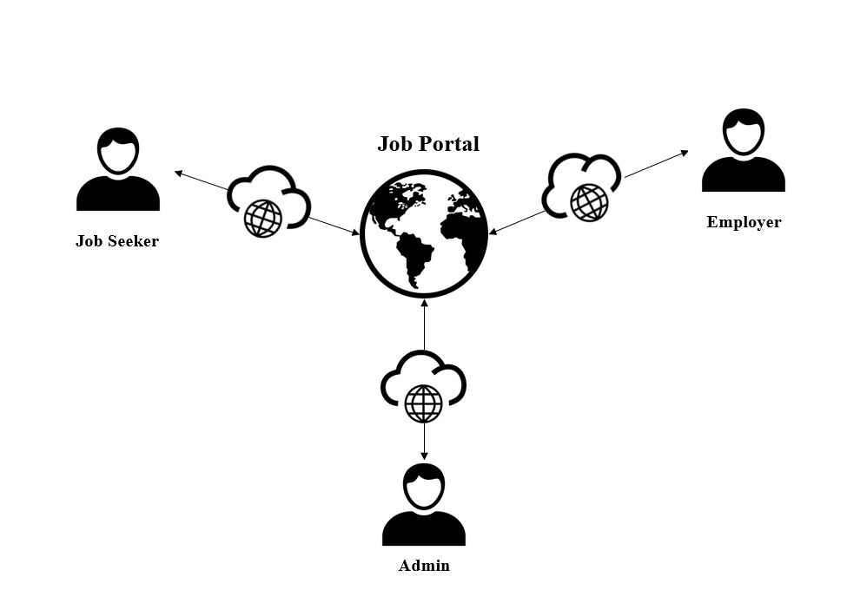

Figure 1. 1 Deployment diagram of Smart Job Portal

Figure 1.1 describes the overall workflow of the system. The users can log in to the website. The admin is responsible for content management. Content management includes adding and updating cities, countries, skills, and industries.

* A Job seeker can search job, apply for job and give feedback.
* An Employer can post a job, manage jobs, view and download CVs.
* The Administrator is able to manage skills, cities, countries and industries.
* The Administrator can monitor job post and member profile.

## Purpose

The purpose is to develop a platform where job seekers can search for a job by city, country, skill, and industry, apply for jobs and enables employers to post their jobs and receive job applications.

## Organization of the document

The following subsections provide an overview of the chapters of the remaining document.



### Chapter 2:

This chapter describes the related applications such as features of Rozee, Indeed, monster, and Smart job portal (The proposed system)

### Chapter 3:

This chapter describes the tools used to develop the project and the technology used for implementation.

### Chapter 4:

This chapter deals with the functional and non-functional requirements of the proposed system. It also describes use cases for the admin panel, the employer, and the job seeker panel. Use case diagrams and sequence diagrams are also in this chapter

### Chapter 5:

This chapter describes the database design and table descriptions.

### Chapter 6:

This chapter describes the system testing and all the test cases for admin, employer, and job seeker.

### Chapter 7:

This chapter has the user manual of the proposed system.

### Chapter 8:

This chapter describes the conclusion and future work for the Smart job portal.

## Summary

This chapter describes the introduction of the Smart job portal. The overview of the proposed system. The purpose of the Smart job portal and its scope. The next chapter contains the study of related systems.

# Chapter 2

# STUDY OF RELATED SYSTEMS

Study of related systems provides insights into the feature and functions of some of the most popular job portals, which are being used in Pakistan and all over the world.

## Rozee (rozee.pk)

One of the most well-known internet job boards, Rozee, matches talent with opportunities. It offers services to both businesses and job searchers by giving them access to the same platform for posting and searching for jobs, respectively.

Around 100,000 employers and 9.5 million professionals use it, making it Pakistan's largest online recruitment platform. Around 1 million job placements have been made using Rozee's platform since it launched, and it possesses Pakistan's biggest searchable CV database.

The features provided by rozee are given below:

* Job Alerts
* Mobile App
* Referral Tracker
* Interview evaluation form
* Test Builder for weeding out the best applicants
* Post a job
* Upload CV
* Create New Folder
* Upload Multiple CVs
* Mailbox
* Auto Emails
* CV Search
* CV Writing Services
* Reported Companies
* Searching by job title, skill or company
* View Profile
* Change password
* Manages Jobs

## Indeed (indeed.com)

Indeed is a reliable job search engine for both companies and job seekers and employers around the world. It is available in 28 languages and more than 60 different nations. The website is designed with search engine techniques similar to those used by Google, enabling job searchers to quickly and conveniently search for and apply to openings that match their qualifications, experience, and career goals. Employers can also utilize the website to identify candidates who meet their hiring needs. Employees looking for new jobs can create a resume on the site, get email notifications when new positions are posted, and interview and hire their chosen candidates. Employers can post jobs, interview, and hire their preferred applications.

Using Indeed.com, job seekers can receive email job notifications. All they need to do set the job alerts preferences for their account. Job seekers can choose to receive daily, weekly, or monthly job alerts whenever a new position is posted.

The features provided by indeed are given below:

* Sponsor Job from Career Sites
* Large Scale Hiring
* Aggregates Jobs Listings
* Email Job Alerts
* Free Job Postings
* Global Talent Pool
* Network/System Integration
* Google-like search engine
* Resume Builder
* Sponsored Jobs
* Mobile Apps
* Easy To Navigate
* Dominant Resource

## Monster (monster.com)

One of the most well-known job portal websites, Monster, matches talent with opportunities. It offers services to both employers and job searchers by giving them access to the same platform for posting and searching for jobs, respectively. Monster is an international job-listing website.

The company also provides a highly rated app for job seekers on Google Play and the Apple App Store. It is advantageous for job seekers, companies since it makes Monster’s services easier to use, and appeals to a society becoming more dependent on smartphones.

The features of the monster are listed below:

* Wide variety of job listings
* Multiple ways to filter jobs
* Read industry overviews
* Library of educational content
* Resume assistance available
* Polish your professional profile
* Employers can post vacancies
* Employers can contact candidates
* Employers can start and stop job postings at any time

## Features of the Proposed System

In the last section, we list the feature of the job portal. The proposed system provides various functions be listed below:

* Search for a job
* Apply for a job
* Upload CV
* Download CV
* Post Job Advertisement
* Update Job Advertisement
* Delete Job Advertisement
* Approve and Update Employer Profile
* Approve and Update Job Advertisement

## User Characteristics

The users who interact with the system are listed below:

### Admin

The Administrator is the user who can manage content (add and update) and approve jobs and profiles.

### Employer

An Employer is a user who can post job advertisements. He can also update or delete job advertisements, select the candidates for the specific job, search CVs sent by job seekers, and view and download CVs.

### Job Seeker

A Job Seeker is a user who can apply for a job according to their qualification, skills, and experience.

## Summary

This chapter covered the study of related systems. There is a description of the Rozee, Indeed, and the Monster. It also describes the feature of the Smart job portal. In the last section, we described the characters, who interact with the system admin, employer, and job seeker. In the next chapter, we describe the tools and technologies used to build the proposed system.

# Chapter 3

# TOOLS & TECHNOLOGIES

The tools and technologies used for the implementation of the proposed system are discussed in this chapter.



## Development Tools

The tools used to build the Smart job portal are visual studio 2019 and SQL Server Management Studio SSMS. There is a brief description for both of the tools that are listed below:

### Visual Studio 2019

Microsoft Visual Studio 2019 is an Integrated Development Environment used to create software, including mobile apps, websites, online applications, and computer programs. In the Smart job portal, visual studio 2019 used for development because of best features includes code editor with itelli-Sense, Debugging and testing, Collaborative Development, Cross-platform development, Extensions, and Customizations. Visual Studio 2019 is a powerful IDE that helps developers to create high-quality applications with ease and efficiency.

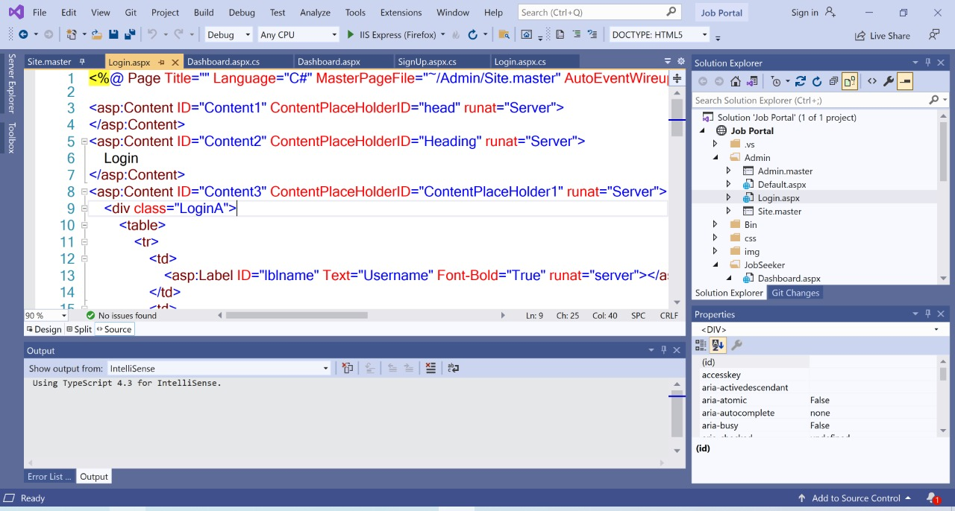

Figure 3. 1 Microsoft Visual Studio 2019

### Microsoft SQL Server 2016

Microsoft SQL Server 2016 was developed by Microsoft Corporation. It has several features, which improve its performance and efficiency. Some key features are query store, in-memory OLTP, always encrypted, stretched database, JSON Support, and many more.

SQL infrastructure manages in an integrated environment called SQL Server Management Studio (SSMS). In the smart job portal, the database is stored in a SQL server management studio and all the queries can be tested there. The database diagram can also make in the SQL Server Management studio. The components of SQL Server such that Azure SQL Database, Azure SQL Managed Instance, SQL Server on Azure VM, and Azure Synapse Analytics may be accessed, configured, managed, administered, and developed using SSMS.

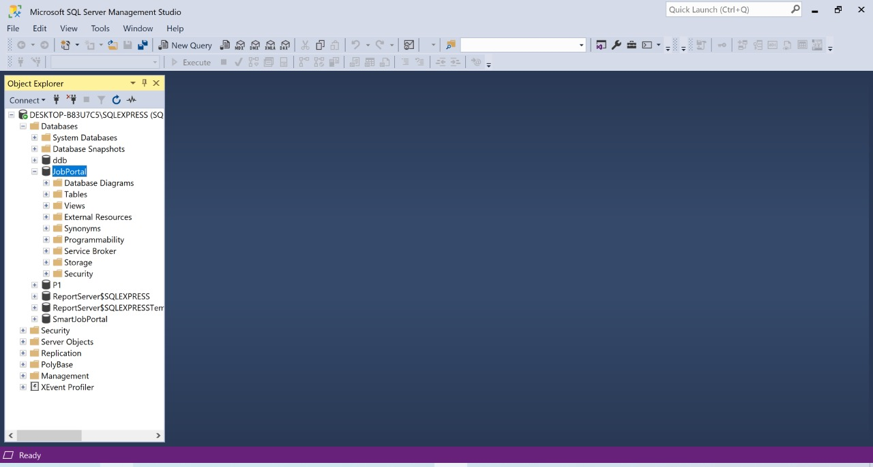

Figure 3. 2 Microsoft SQL Server Management Studio 2016

## Technologies

### The technology used to implement the proposed system is ASP .NET (HTML, CSS, JS, and C#).

### ASP .Net

A web development platform called ASP.NET offers a programming model, a thorough software architecture, and several services needed to create reliable web applications for PCs and mobile devices. ASP.NET is a free online framework for creating efficient websites and web apps using HTML, CSS, and JavaScript. An alternative to ASP.NET is ASP.NET Core.

## Summary:

The tools and technologies used to build the Smart job portal are described in this chapter. The technology is ASP .net (HTML, CSS, JS, and C#) for implementing the proposed system. The tools used to build the Smart job portal are Visual Studio 2019 and SQL Server Management Studio (SSMS).In the next chapter; we discussed the functional and non-functional requirements of the Smart job portal. Moreover, Use cases, use case diagrams, and sequence diagrams are also included in the next chapter.

# Chapter 4

# SYSTEM ANALYSIS

System Analysis describes the functional and non-functional requirements of the proposed system. The use case diagrams and sequence diagrams are in this chapter.



## Functional Requirements

The functional requirements of the proposed system are in this section.



### Admin Module



#### Login

The system enables the user to log in.

#### Manage Cities

The system enables the user to add and update cities.

#### Manage Countries

The system enables the user to add and update countries.

#### Manage Skills

The system enables the user to add and update skills.

#### Manage Industries

The system enables the user to add and update industries.

#### Approve Member Profile

The system enables the user to approve the Member profiles. Member profiles can be either Employer Profile or Employee Profile.

#### Approve Job Advertisements

The system enables the user to approve the Job Advertisements.



### Employer & Job Seeker Module



#### Registration

The system enables the user to register.

#### Login

The system enables the user to log in.

#### Post a Job Advertisement

The system enables the user to post a job Advertisement.

#### View CVs

The system enables the user to view a CV.

#### Download CVs

The system enables the user to download CVs.

#### Search for Job

The system enables users to search for jobs by city, country, skills, and industry. According to the user's interest, the job searched.

#### Apply for Job

The system enables the user to apply for the job.

#### Upload CV

The system enables the user to upload CV.

## Non-Functional Requirements



### Performance

The system performs its requested tasks in an acceptable time.

### Reusability

The source code of the proposed system is reusable and used in other applications with some modifications.

### Maintainability

The system is maintainable, and the code can be changed and modified according to valid requirements.

### Usability

The Web-based system provides a graphical user interface for its users. It is a user-friendly interface.

### Availability

The system can be available 20 to 24/7 since it is a website, and users can access the website from anywhere.

### Security

All users are authenticated and authorized. If the user gives a valid email and password, then log in to the website and access the software. In another case, he gets an error message.

### Reliability

The system consistently performs the specified function without failure. The Smart job portal is efficient and reliable.

### Portability

The system can be able to run under different computing environments. It is easy to shift it from one platform to another.

## Use Cases

The use cases for the proposed system are written in this section, which are discussed below. The admin, employer and job seeker

### Admin Module



#### Use case 1 - Login

The user would be able to login if the username and password are correct.

Table 4. 1 Admin Login Use Case

|  |  |
| --- | --- |
| **ID** | UC-01 |
| **Title** | Login |
| **Description** | The user enters credentials to login to the system. |
| **Actor** | Admin |
| **Preconditions** | N/A |
| **Post Conditions** | Admin will be redirected to dashboard. |
| **Basic steps** | 1. The user would enter username. 2. The user would enter password. 3. The user would click on the login button. |
| **Exception** | If user enter invalid username or password than an error will occur and he will not log in. |

#### Use case 2 – Manage Countries

The user would be able to manage countries.

Table 4. 2 Admin Manage Countries Use Case

|  |  |
| --- | --- |
| **ID** | UC-02 |
| **Title** | Manage Countries |
| **Description** | The user manages countries in which he/she can either add country or update country. |
| **Actor** | Admin |
| **Preconditions** | Sign in |
| **Post Conditions** | Admin will be added or updated countries successfully. |
| **Basic steps** | 1. The user would click on manage countries (From the Menu). The user would be redirected to manage countries page. 2. The user would click on add (update) button. 3. The user would enter the country name. 4. The user would enter the dialing code. 5. The user would enter the domain code. 6. The user would upload the flag image. 7. The user would click on save button. 8. The system would show the message of “country added or updated” to the user. |

#### Use case 3 – Manage Cities

The user would be able to manage cities.

Table 4. 3 Admin Manage Cities Use Case

|  |  |
| --- | --- |
| **ID** | UC-03 |
| **Title** | Manage Cities |
| **Description** | The user manages cities in which he/she can either add city or update city. |
| **Actor** | Admin |
| **Preconditions** | Sign in |
| **Post Conditions** | Admin will be added or updated cities successfully. |
| **Basic steps** | 1. The user would click on manage cities (From the Menu). The user would be redirected to manage cities page. 2. The user would click on add (update) button. 3. The user would enter the city name. 4. The user would enter the zip code. 5. The user would click on save button. 6. The system would show the message of “city added or updated” to the user. |

#### Use case 4 – Manage skills

The user would be able to manage skills.

Table 4. 4 Admin Manage Skills Use Case

|  |  |
| --- | --- |
| **ID** | UC-04 |
| **Title** | Manage Skills |
| **Description** | The user manages skills in which he/she can either add skill or update skill. |
| **Actor** | Admin |
| **Preconditions** | Sign in |
| **Post Conditions** | Admin will be added or updated skills successfully. |
| **Basic steps** | 1. The user would click on manage skills (From the Menu). The user would be redirected to the manage skills page. 2. The user would click on add (update) button. 3. The user would enter the skill name. 4. The user would click on the save button. 5. The system would the message of “skill added or updated” to the user. |

#### Use case 5 – Manage industries

The user would be able to manage industries.

Table 4. 5 Admin Manage Industries Use Case

|  |  |
| --- | --- |
| **ID** | UC-05 |
| **Title** | Manage Industries |
| **Description** | The user manages industries in which he/she can either add industry or update industry. |
| **Actor** | Admin |
| **Preconditions** | Sign in |
| **Post Conditions** | Admin will be added or updated industries successfully. |
| **Basic steps** | 1. The user would click on manage industries (From the Menu). The user would be redirected to manage industries page. 2. The user would click on add (update) button. 3. The user would enter the industry name. 4. The user would click on save button. 5. The system would show the message of “industry added or updated” to the user. |

#### Use case 6 – Approve Member Profile

The user would be able to approve the member profile.

Table 4. 6 Admin Approve Member Profile Use Case

|  |  |
| --- | --- |
| **ID** | UC-06 |
| **Title** | Approve Member Profile |
| **Description** | The user approves the member profile. The member profile would be either the employer profile or the job seeker profile. |
| **Actor** | Admin |
| **Preconditions** | Signup |
| **Post Conditions** | The Member profile will be approved successfully. |
| **Basic steps** | 1. The user would click on approve member profile (From the Menu). The user would be redirected to approve member profile page. 2. The user would click on the view button. All the information of members such as name, email, password and phone number would be visible to user. 3. The user would click on approved button. 4. The system would show the message of “member profile approved” to the user. |

#### Use case 7 – Approve Job Advertisement

The user would be able to approve the job advertisement.

Table 4. 7 Admin Approve Job Advertisement Use Case

|  |  |
| --- | --- |
| **ID** | UC-07 |
| **Title** | Approved Job Advertisement |
| **Description** | The user approves the job advertisement, which are posted by employers. |
| **Actor** | Admin/ Employer |
| **Preconditions** | The employer posted a job advertisement. |
| **Post Conditions** | Admin will be approved the job advertisement successfully. |
| **Basic steps** | 1. The user would click on approve job advertisement (From the Menu). The user would be redirected to approve job advertisement page. 2. The user would click on the view button. All information such as Title, Description, skills, location, career level, positions, qualification, experience, and salary of posted job would be visible to the user. 3. The user would click on approved button. 4. The system would show the message of “job advertisement approved” to the user. |

### Employer & Job Seeker Module



#### Use case 1 – Job Seeker Sign Up

The user would be able to register his/her account in the smart job portal.

Table 4. 8 Job Seeker Signup Use Case

|  |  |
| --- | --- |
| **ID** | UC-08 |
| **Title** | Sign Up |
| **Description** | The user creates his/her account in the smart job portal. |
| **Actor** | Job Seeker |
| **Preconditions** | The user is at the Sign-Up page. |
| **Post Conditions** | The user will be redirected to the login page. |
| **Basic steps** | 1. Click on the sign-up button. 2. The user would enter the first name. 3. The user would enter the last name. 4. The user would enter the email. 5. The user would enter the password. 6. The user would enter the phone number. 7. The user would click on Create account button. 8. The system would show the message “account created successfully” to the user. 9. The user would get the email for verification of the account. |

#### Use case 2 – Employer Sign Up

The user would be able to register his/her account in the smart job portal.

Table 4. 9 Employer Signup Use Case

|  |  |
| --- | --- |
| **ID** | UC-09 |
| **Title** | Sign Up |
| **Description** | The user creates his/her account in the smart job portal. |
| **Actor** | Employer |
| **Preconditions** | The user is at the Sign Up page. |
| **Post Conditions** | User will go to login page. |
| **Basic steps** | 1. Click on login button. 2. The user would enter the first name. 3. The user would enter the last name. 4. The user would enter the email. 5. The user would enter the company name. 6. The user would enter the password. 7. The user would enter the mobile number. 8. The user would enter the city name. 9. The user would enter the CNIC. 10. The user would click on create account button. 11. The system would show the message of “account created successfully” to the user. 12. The user would get the email for verification of the account. |

#### Use case 3 – Login

The user would be able to login if the email and password are correct.

Table 4. 10 Employer & Job Seeker Login Use Case

|  |  |
| --- | --- |
| **ID** | UC-10 |
| **Title** | Login |
| **Description** | The user enters credentials to login to the system. |
| **Actor** | Employer / Job Seeker |
| **Preconditions** | N/A |
| **Post Conditions** | User will be redirected to dashboard. |
| **Basic steps** | 1. The user would enter email. 2. The user would enter password. 3. The user would click on the login button. |
| **Exception** | If user enter invalid email or password than an error will occur and he will not log in. |

#### Use case 4 – Forgot Password

The user would be able to get his/her password on email.

Table 4. 11 Employer & Job Seeker Forgot Password Use Case

|  |  |
| --- | --- |
| **ID** | UC-11 |
| **Title** | Forgot Password |
| **Description** | The user forgets the password and the password send to the registered email. |
| **Actor** | Employer, Job Seeker |
| **Preconditions** | The user is on the login page. |
| **Post Conditions** | The user will gets a password on his/her registered email. |
| **Basic steps** | 1. The user would enter the email. 2. The user would enter the invalid password. 3. The user would get the error of invalid password. 4. The user would click on forgot password button. 5. The user would redirected to the page where he/she would enters the email. 6. The system would show message of “the password sends to email” to the user. |

#### Use case 5 – Post a Job

The user would be able to post a job.

Table 4. 12 Employer Post a job Use Case

|  |  |
| --- | --- |
| **ID** | UC-12 |
| **Title** | Post a Job |
| **Description** | The user posted a job advertisement. |
| **Actor** | Employer |
| **Preconditions** | Signup |
| **Post Conditions** | The employer will be posted job advertisement successfully. |
| **Basic steps** | 1. The user would click on post a job (From the Menu). He would redirected to post a job page. 2. The user would enter the job Title. 3. The user would enter the job Description. 4. The user would enter Skills. 5. The user would enter the required career level for this job and number of positions available. 6. The user would enter the salary range. 7. The user would enter the job location. 8. The user would click on post a job button. 9. The job is posted successfully. |

#### Use case 6 – Manage Job Advertisement

The user would be able to manage job advertisements.

Table 4. 13 Employer Manage Jobs Advertisements Use Case

|  |  |
| --- | --- |
| **ID** | UC-13 |
| **Title** | Manage job advertisements |
| **Description** | The user manages job advertisement in which he/she can either delete or update job advertisements. |
| **Actor** | Employer |
| **Preconditions** | Sign in |
| **Post Conditions** | The employer will be managed the job advertisement successfully. |
| **Basic steps** | 1. The user would click on manage jobs (From the Menu). The user would be redirected to manage jobs page. 2. The user would click on delete (update) button. 3. The system would show the message of “job advertisement deleted” to the user. |

#### Use case 7 – Search Job

The user would be able to search the job according to his qualification.

Table 4. 14 Job Seeker Search Job Use Case

|  |  |
| --- | --- |
| **ID** | UC-14 |
| **Title** | Search Jobs |
| **Description** | The user searches the job according to his/her qualification. |
| **Actor** | Job Seeker |
| **Preconditions** | The job seeker is at the home page of job portal. |
| **Post Conditions** | The job seeker will be searched the job successfully. |
| **Basic steps** | 1. The user would enter the job title. 2. The user would enter the skill, city or company. 3. The user would click on search button. 4. The system would show the message of “job searched successfully” to the user. |

#### Use case 8 – Apply for Job

The user would be able to apply for job related to his interest and qualification.

Table 4. 15 Job Seeker Apply for Job Use Case

|  |  |
| --- | --- |
| **ID** | UC-15 |
| **Title** | Apply for job |
| **Description** | The user apply for job according to his interest and qualification. |
| **Actor** | Job Seeker |
| **Preconditions** | Signup |
| **Post Conditions** | The job seeker will be applied for job successfully. |
| **Basic steps** | 1. The user would enter the job title. 2. The user would select the city. 3. The user would click on search button. 4. The system would show the vacancies to the user. 5. The user would click on apply button. 6. The user would enter the desired salary 7. The user would enter the current salary. 8. The user would upload the CV. 9. The user would click on submit button. 10. The system would show the message of “application submitted” to the user. |

#### Use case 7 – View and Download CV’s

The user would be able to view and download CV’s send by job seeker’s.

Table 4. 16 Employer View and Download CV’s Use Case

|  |  |
| --- | --- |
| **ID** | UC-16 |
| **Title** | View and Download CV’s |
| **Description** | The user views or downloads the CV’s send by job seeker’s. |
| **Actor** | Employer |
| **Preconditions** | The user is on the dashboard. |
| **Post Conditions** | The employer will be viewed or downloaded CV successfully. |
| **Basic steps** | * + - 1. The user would click on manage CV’s (From the Menu). The user would be redirected to manage CV page.       2. The system would show different CV’s to the employer send by Job Seeker.       3. The user click on view button.       4. The system would redirected the user to the new window where he can view the CV.       5. The user would click on the download button.       6. The system would show the message of “CV downloaded” to the user. |

## Use Case Diagrams



### Admin

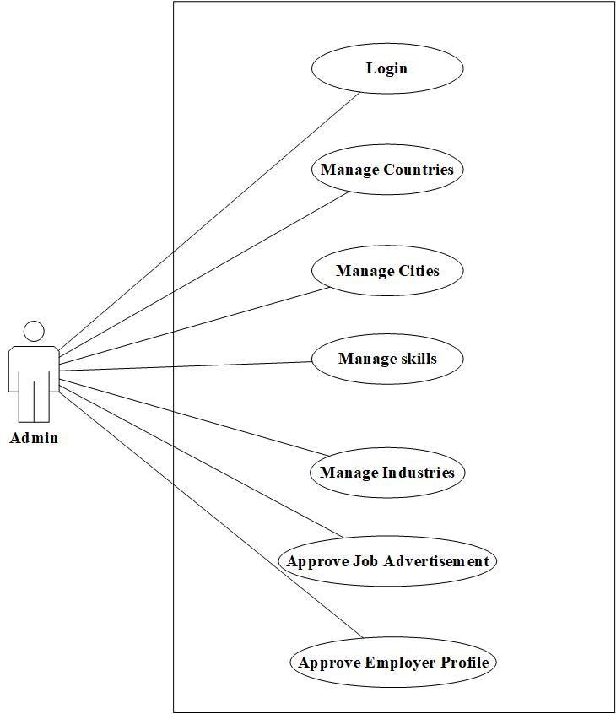

Figure 4. 1 Use Case Diagram for Admin

The admin would do the content management and would perform the following functions manage countries, manage cities, manage skills, manage industries, and approve Job Advertisements and Approve Member profiles.

### Employer & Job Seeker

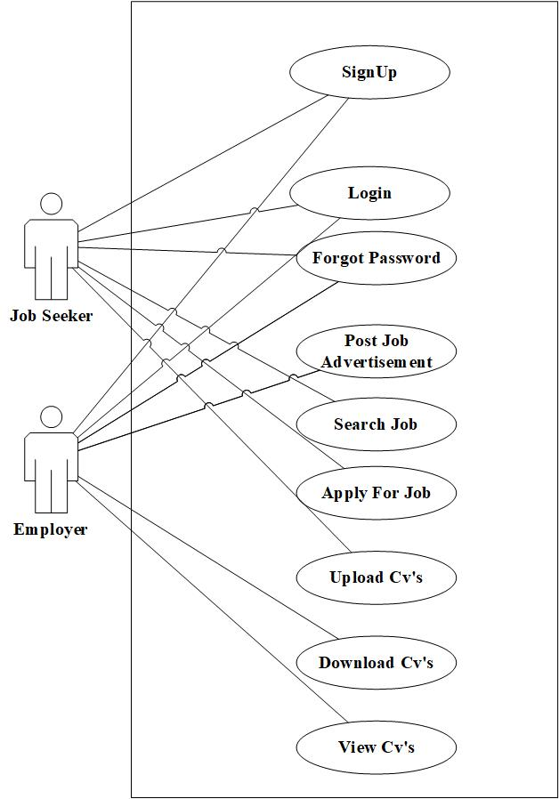

Figure 4. 2 Use Case Diagram for Employer & Job Seeker

The employer would register, log in, reset the password, post job advertisements, and view and download cvs. The job seeker would register, log in, reset their password, search for jobs by country, city, industry, and skill, apply for jobs, apply for the job, and upload their CV.

## Sequence Diagrams

The sequence diagrams describes the flow of functions. How the messages passes and how the functionality is performed can be describe diagrammatically.



### Admin



#### Sequence Diagram for Admin Login

Figure 4. 3 displays the sequence of steps for the login of admin.

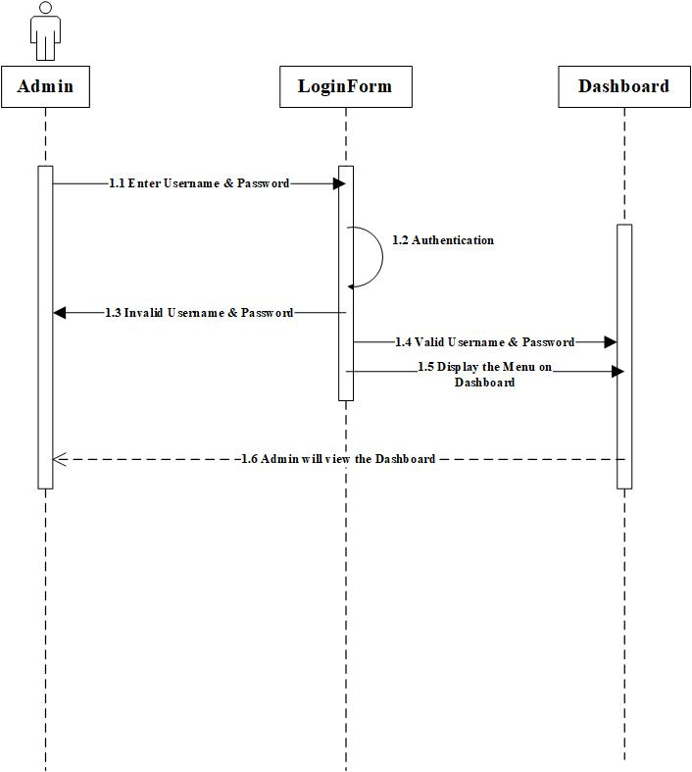

Figure 4. 3 Sequence Diagram for Admin Login

#### Sequence Diagram for Admin Approve Member Profile

Figure 4. 4 displays the sequence of steps for approve member profile of the admin.

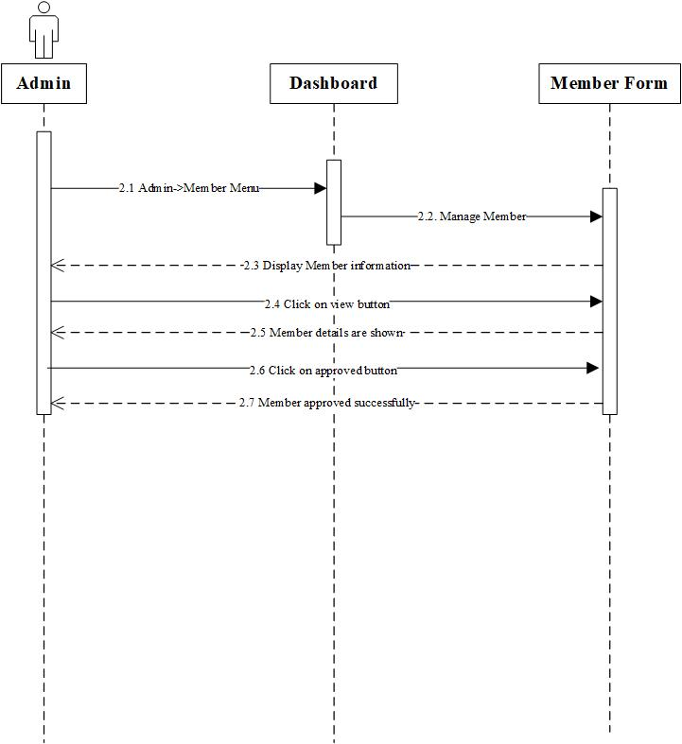

Figure 4. 4 Sequence Diagram for Admin Approve Member Profile

#### Sequence Diagram for Admin Approve Job Advertisement

Figure 4. 5 displays the sequence of steps for approve job advertisement of the admin.

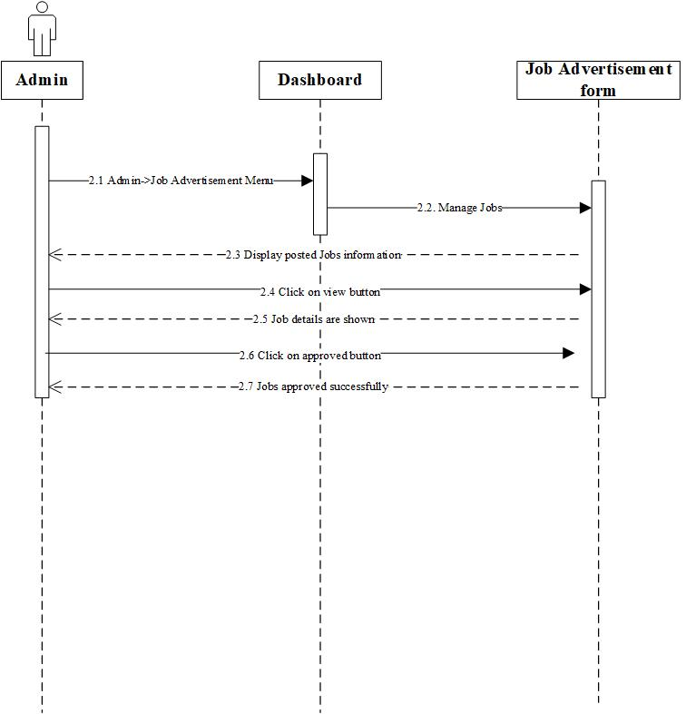

Figure 4. 5 Sequence Diagram for Admin Approve Job Advertisement

#### Sequence Diagram for Admin Manage Countries

Figure 4. 6 displays the sequence of steps for manage countries of admin.

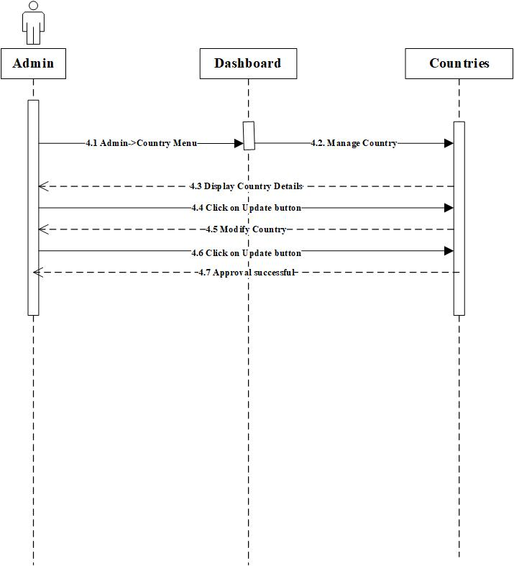

Figure 4. 6 Sequence Diagram for Admin Manage Countries

#### Sequence Diagram for Admin Manage Cities

#### Figure 4. 7 displays the sequence of steps for manage cities of admin.

#### adminSeqCity 4

Figure 4. 7 Sequence Diagram for Admin Manage Cities

#### Sequence Diagram for Admin Manage Industries

Figure 4. 8 displays the sequence of steps for manage industries of admin.

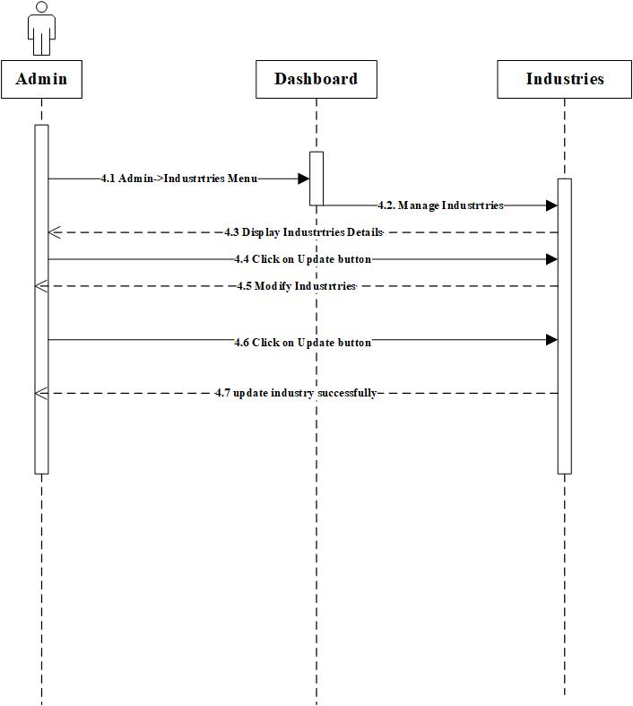

Figure 4. 8 Sequence Diagram for Admin Manage Industries

#### Sequence Diagram for Admin Manage Skills

Figure 4. 9 displays the sequence of steps for manage skills of admin.

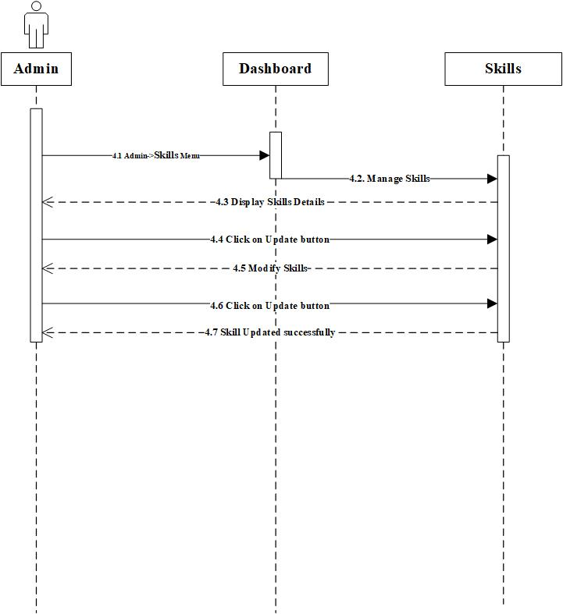

Figure 4. 9 Sequence Diagram for Admin Manage Skills

### Employer & Job Seeker



#### Sequence Diagram for Employer Sign Up

Figure 4. 10 displays the sequence of steps for signup of employer.

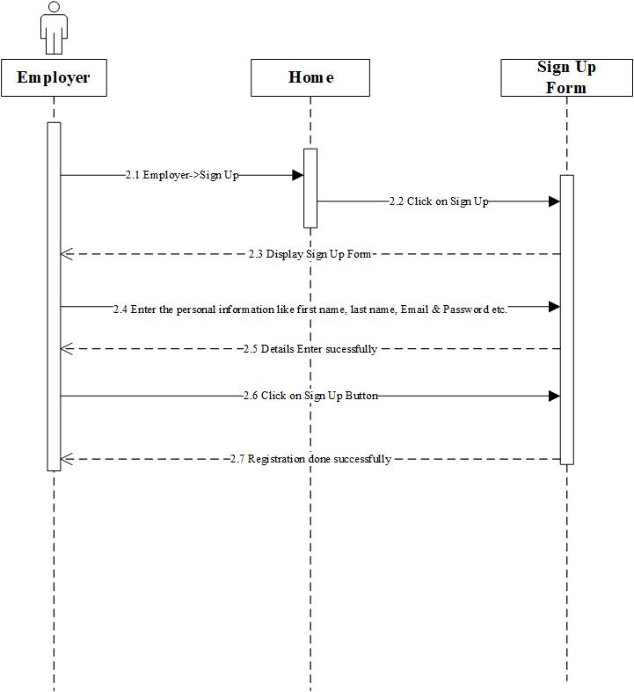

Figure 4. 10 Sequence Diagram for Employer Signup

#### Sequence Diagram for Employer Login

Figure 4. 11 displays the sequence of steps for login of employer.

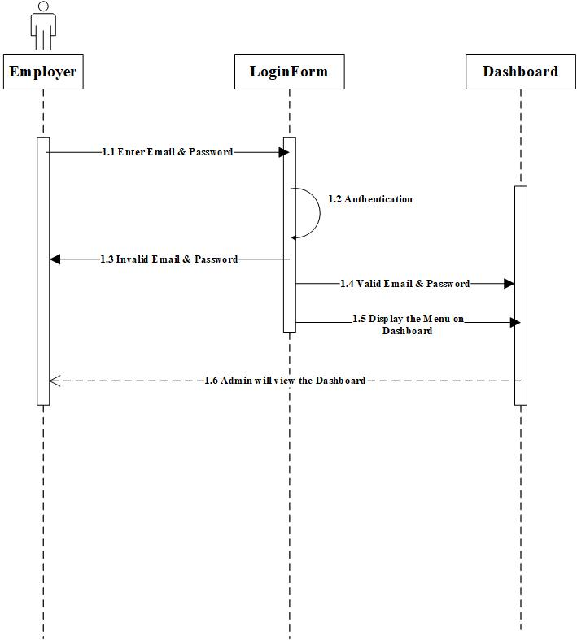

Figure 4. 11 Sequence Diagram for Employer Login

#### Sequence Diagram for Employer Post a Job

Figure 4. 12 displays the sequence of steps for post a job advertisement of employer.

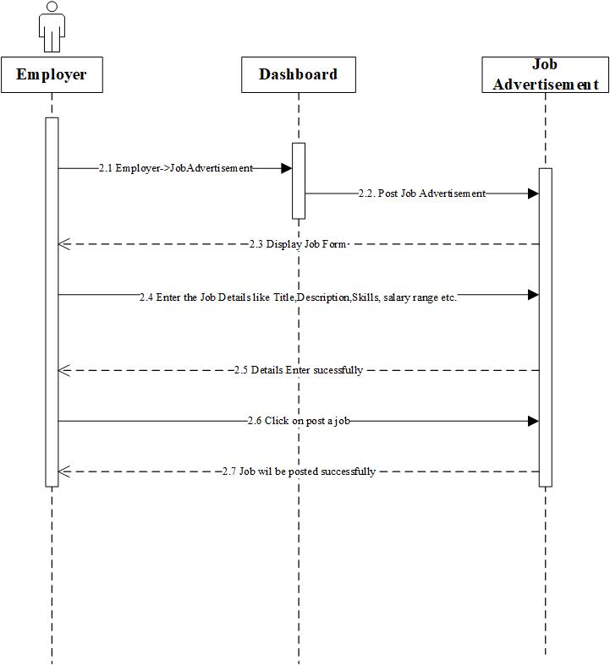

Figure 4. 12 Sequence Diagram for Employer Post a Job

#### Sequence Diagram for Job Seeker Sign Up

Figure 4. 13 displays the sequence of steps for signup of job seeker.

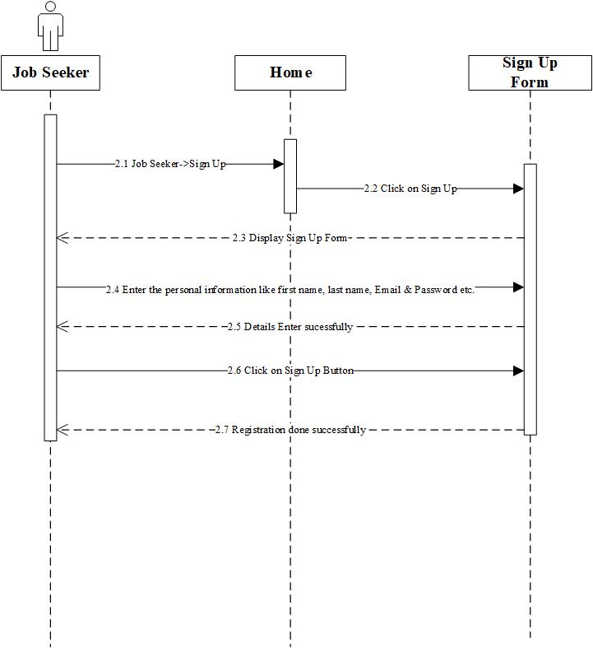

Figure 4. 13 Sequence Diagram for Job Seeker Signup

#### Sequence Diagram for Job Seeker Login

Figure 4. 14 displays the sequence of steps for login of job seeker.

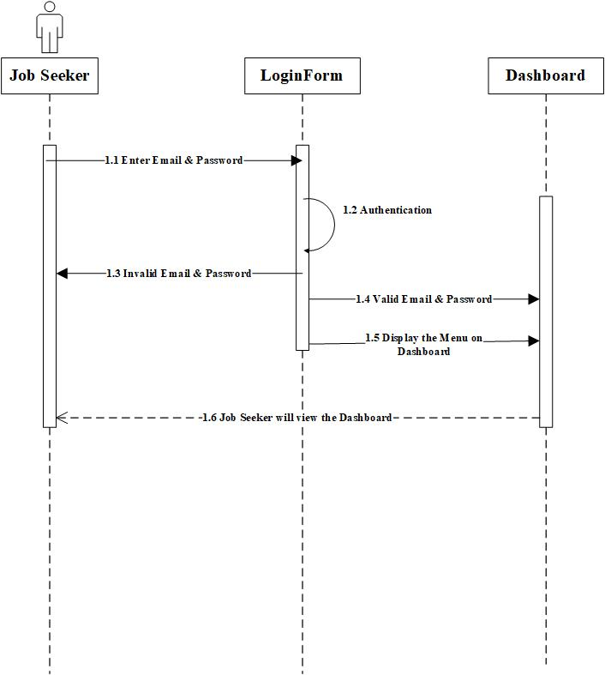

Figure 4. 14 Sequence Diagram for Job Seeker Login

#### Sequence Diagram for Job Seeker Apply for job

Figure 4. 15 displays the sequence of steps for apply for job of job seeker.

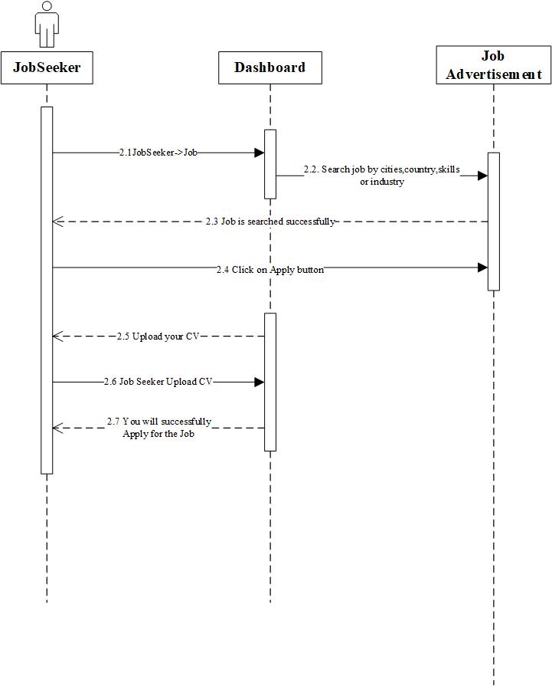

Figure 4. 15 Sequence Diagram for Job Seeker Apply for Job

## Summary

In this chapter, functional and non-functional requirements are covered. Use cases, use case diagrams, and sequence diagrams are discussed. In the next chapter, we discussed system design, table design and user interface design.

# Chapter 5

# SYSTEM DESIGN



## Database Design

Figure 5. 1 shows the different tables like Member, City, Country, Companies, Skill, Industry, Employer Profile, Job Seeker Profile, etc. The member table can store the member login details. The Member is either Employer or Job Seeker. Therefore, there are different tables for employer profile & job seeker profile. The Cities table contains information about the cities. The skills table has information about the skills. The companies table contains information about companies.

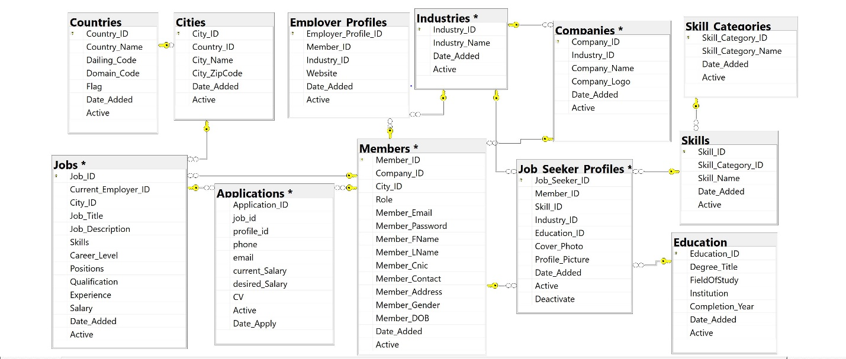

Figure 5. 1 Database diagram for smart job portal

## Tables Description

### Countries

Table 5. 1 Countries Database Design

|  |  |  |  |
| --- | --- | --- | --- |
| **Countries** | | | |
| **S No.** | **Name** | **Data Type** | **Description** |
| 1 | Country_ID | Numeric(18,0) | Primary key |
| 2 | Country_Name | Varchar(50) | Name of country (Pakistan) |
| 3 | Dailing_Code | Numeric(18,0) | Dialing code or mobile code (+92) |
| 4 | Domain_Code | Varchar(50) | Domain code or country code (.pk) |
| 5 | Flag | Image | The flag of the country |
| 6 | Date_Added | Datetime | Default : getdate() |
| 7 | Active | Bit | Default : 1 |

### Cities

Table 5. 2 Cities Database Design

|  |  |  |  |
| --- | --- | --- | --- |
| **Cities** | | | |
| **S No.** | **Name** | **Data Type** | **Description** |
| 1 | City_ID | Numeric(18,0) | Primary key |
| 2 | Country_ID | Numeric(18,0) | Foreign key |
| 3 | City_Name | Varchar(50) | Name of city (Rawalpindi) |
| 4 | City_ZipCode | Numeric(18,0) | Zip code of city (45600, 46300) |
| 5 | Date_Added | Datetime | Default : getdate() |
| 6 | Active | bit | Default : 1 |

### Skills

Table 5. 3 Skills Database Design

|  |  |  |  |
| --- | --- | --- | --- |
| **Skills** | | | |
| **S No.** | **Name** | **Data Type** | **Description** |
| 1 | Skill_ID | Numeric(18,0) | Primary key |
| 2 | SkillCategory_ID | Numeric(18,0) | Foreign key |
| 3 | Skill_Name | Varchar(50) | Name of skill (Teamwork) |
| 4 | Date_Added | Datetime | Default : getdate() |
| 5 | Active | bit | Default : 1 |

### Industries

Table 5. 4 Industries Database Design

|  |  |  |  |
| --- | --- | --- | --- |
| **Industries** | | | |
| **S No.** | **Name** | **Data Type** | **Description** |
| 1 | Industry_ID | Numeric(18,0) | Primary key |
| 2 | Industry_Name | Varchar(50) | Name of industry (Information Technology) |
| 3 | Date_Added | Datetime | Default : getdate() |
| 4 | Active | Bit | Default : 1 |

### Companies

Table 5. 5 Companies Database Design

|  |  |  |  |
| --- | --- | --- | --- |
| **Companies** | | | |
| **S No.** | **Name** | **Data Type** | **Description** |
| 1 | Company_ID | Numeric(18,0) | Primary key |
| 2 | Company_Name | Varchar(50) | Name of company (Stack over flow) |
| 3 | Company_Logo | Varbinary(Max) | The logo of the company. |
| 3 | Date_Added | Datetime | Default : getdate() |
| 4 | Active | bit | Default : 1 |

### Members

Table 5. 6 Members Database Design

|  |  |  |  |
| --- | --- | --- | --- |
| **Members** | | | |
| **S No.** | **Name** | **Data Type** | **Description** |
| 1 | Member_ID | Numeric(18,0) | Primary key |
| 2 | City_ID | Numeric(18,0) | Foreign key |
| 3 | Role | char(1) | Either the member is the employer or job seeker |
| 3 | Member_FName | Varchar(50) | First Name of member (Maha, Nasir, Adnan) |
| 4 | Member_LName | Varchar(50) | Last Name of member (Shahid, Khan, Rajpoot) |
| 5 | Member_Email | Varchar(50) | Email of member (Maha_Shahid1@outlook.com) |
| 6 | Member_Password | Varchar(50) | Password of member for the account (Maha@442351) |
| 7 | Member_Cnic | Varchar(50) | Cnic of the member (37405-9607231-6) |
| 8 | Member_Contact | Varchar(50) | Contact number of the member (03335293287) |
| 9 | Member_Address | Varchar(50) | Address of the member ( house Number 543, Lane No. 3 Tulsa Road Lalazar Rawalpindi) |
| 10 | Member_Gender | Varchar(50) | Gender of member (Male or female) |
| 11 | Date_Added | Datetime | Default : getdate() |
| 12 | Active | Bit | Default : 1 |

### Applications

Table 5. 7 Applications Database Design

|  |  |  |  |
| --- | --- | --- | --- |
| **Applications** | | | |
| **S No.** | **Name** | **Data Type** | **Description** |
| 1 | Application_ID | Numeric(18,0) | Primary key |
| 2 | Job_ID | Numeric(18,0) | Foreign key |
| 3 | Member_ID | Numeric(18,0) | Foreign key |
| 4 | Current_Salary | Numeric(18,0) | The current salary of the member. |
| 5 | Desired_Salary | Numeric(18,0) | The expected salary of the member. |
| 6 | CV | Varbinary(MAX) | CV or resume of the member. |
| 7 | Date_Added | Datetime | Default : getdate() |
| 8 | Active | Bit | Default : 1 |

### Jobs

Table 5. 8 Jobs Database Design

|  |  |  |  |
| --- | --- | --- | --- |
| **Jobs** | | | |
| **S No.** | **Name** | **Data Type** | **Description** |
| 1 | Job_ID | Numeric(18,0) | Primary key |
| 2 | CurrentEmployer_ID | Numeric(18,0) | Foreign key |
| 3 | City_ID | Numeric(18,0) | Foreign key |
| 4 | Job_Title | Varchar(50) | The title of the job. |
| 5 | Job_Description | Varchar(MAX) | The description of the job. |
| 6 | Skills | Varchar(50) | Skills required for the job. |
| 7 | Career_level | Varchar(50) | Career level of job (Student, Intern Experience) |
| 8 | Positions | Numeric(18,0) | Number of posts vacant for the job. |
| 9 | Qualification | Varchar(50) | Qualification for job. (Matric, Intermediate, BS, MS, PHD) |
| 10 | Experience | Varchar(MAX) | Experience required for job (1year – 3year) |
| 11 | Salary | Varchar(MAX) | Salary range of the job.(5000 - 10000) |
| 12 | Date_Added | Datetime | Default : getdate() |
| 13 | Active | bit | Default : 1 |

## User Interface Designs

The different user interfaces for the Smart job portal are in this sub-section. The admin, employer, and job seeker interact with the system by login. The user has to signup first with a valid email, then login with the authorized email and password.

### User Interface 1 – Sign Up

Figure 5. 2 shows the sign screen for user.

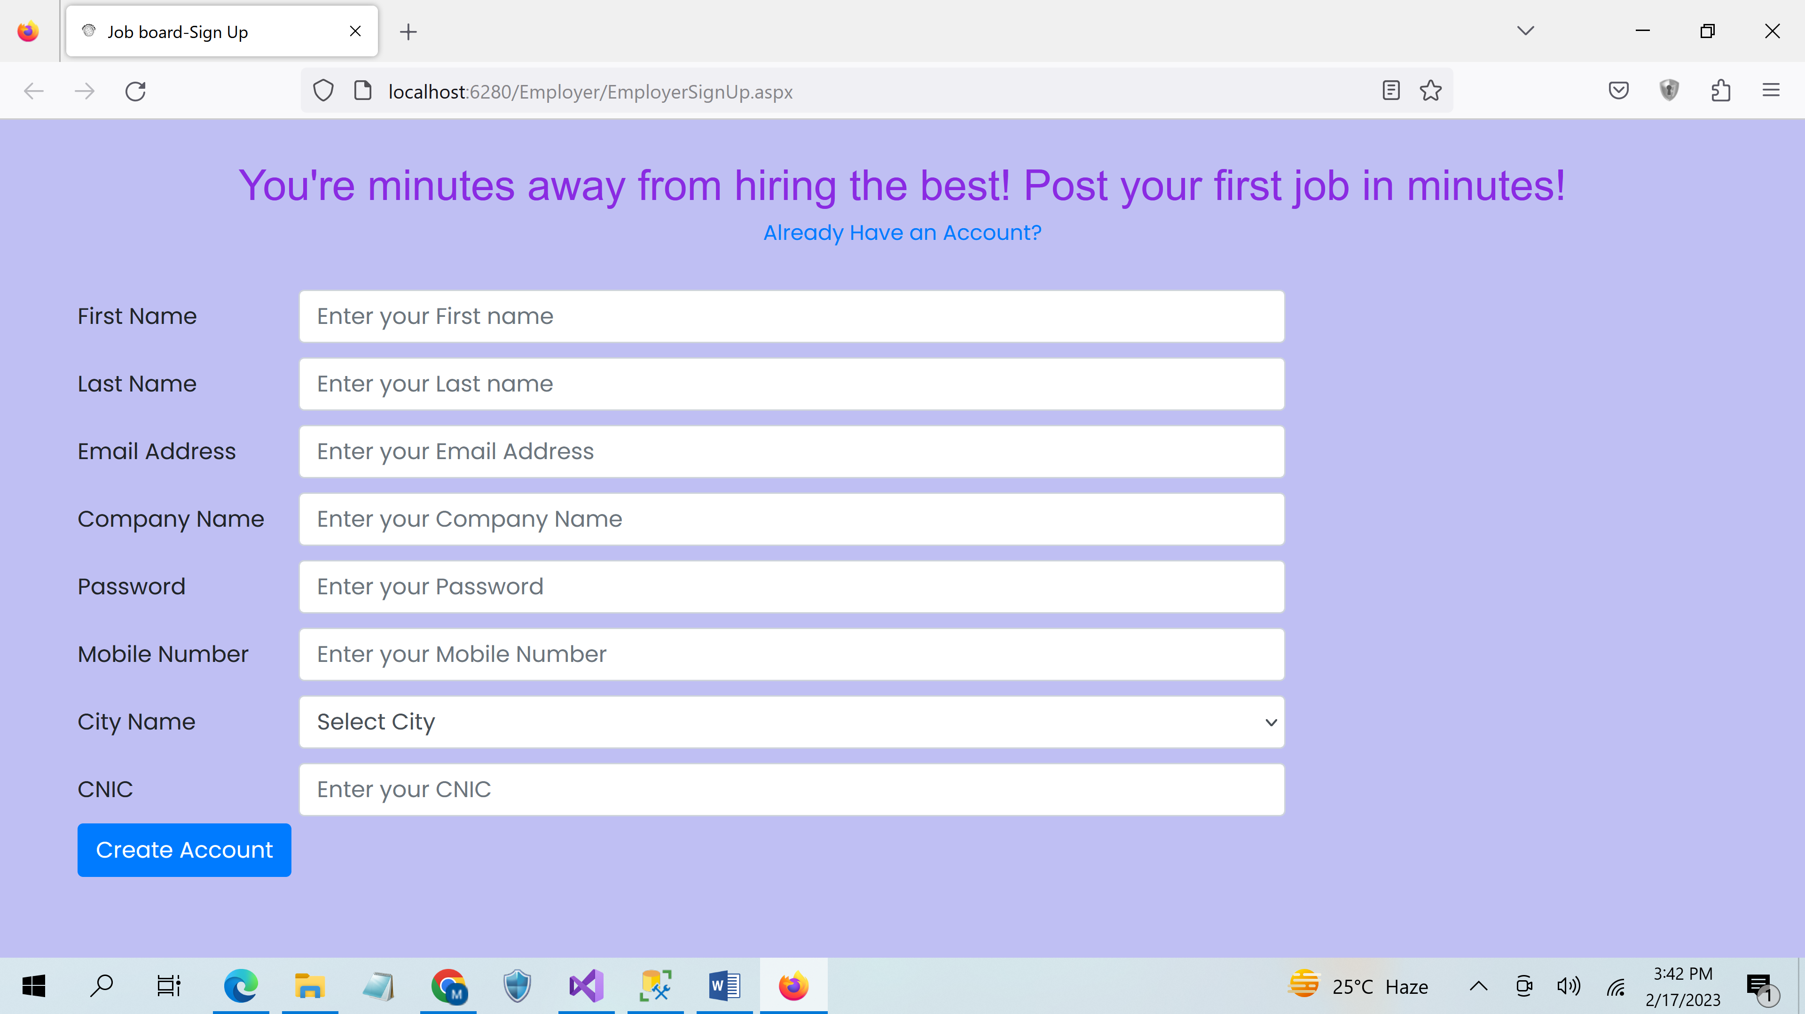

Figure 5. 2 Sign Up

### User Interface 2 - Login

Figure 5. 3 shows the login screen for the user.

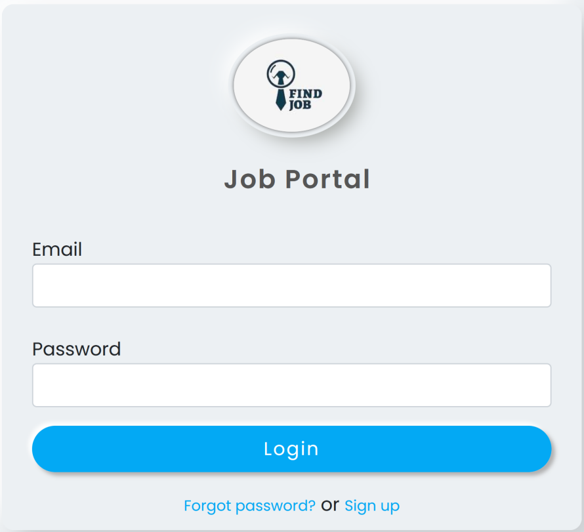

Figure 5. 3 Login

### User Interface 3 – Post a Job

Figure 5. 4 shows the post a job screen for the employer. The user has to enter all the required information. Then, click on post a job. After clicking on post a job button. He gets a message of job is posted successfully.

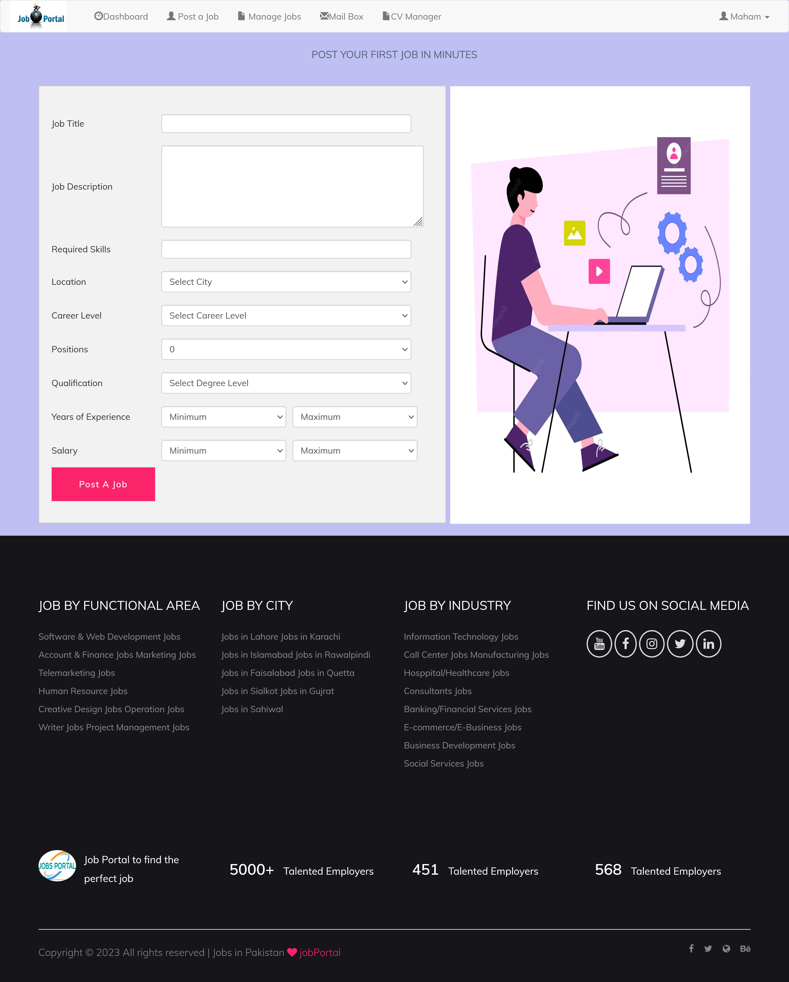

Figure 5. 4 Post a Job

### User Interface 4 – Manage Job Advertisement

Figure 5. 5 shows the Manage Jobs screen for the employer. The employer can manage jobs in which he can add and delete the posted job.

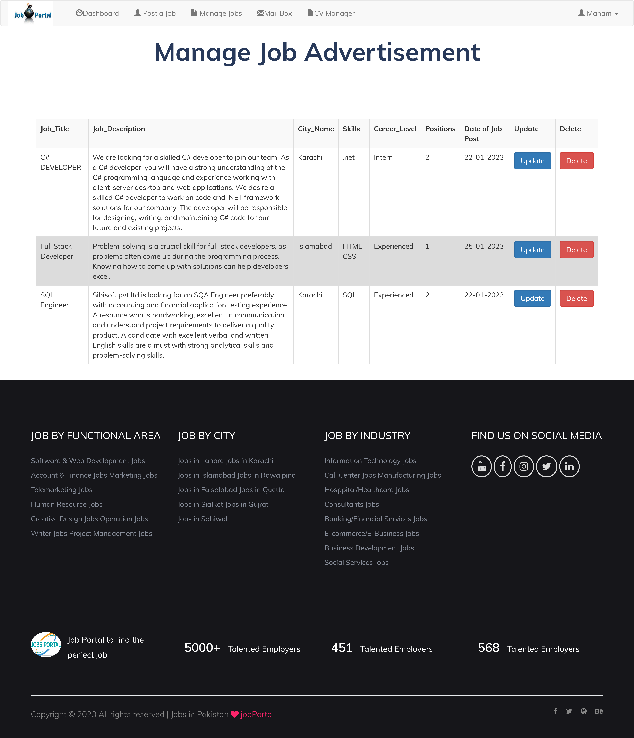

Figure 5. 5 Manage Job Advertisement

### User Interface 5 – View or Download CV’s

Figure 5. 6 shows the view or download CV’s screen for the employer. The user is able to view CV by clicking on the view button. The user is able to Download CV by clicking on the download button.

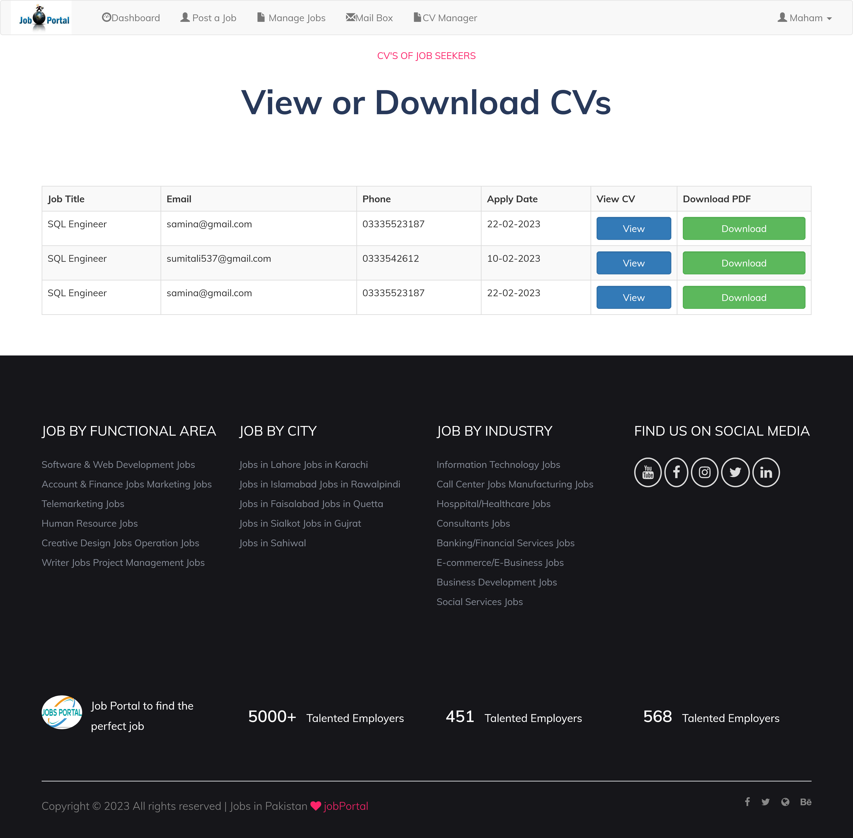

Figure 5. 6 View or Download CV’s

### User Interface 6 – Search a Job

Figure 5. 7 shows the search a job screen for the job seeker. The user can enters the job title and select the city. Click on search button the user gets the jobs related to his interest.



Figure 5. 7 Search a Job

### User Interface 7 – Result of Search Job

Figure 5. 8 shows the result of searched jobs screen for the job seeker. The user enters the title and select the city, and then the user clicks on search job button he redirects to this screen where he can see the searched jobs related to his interest.

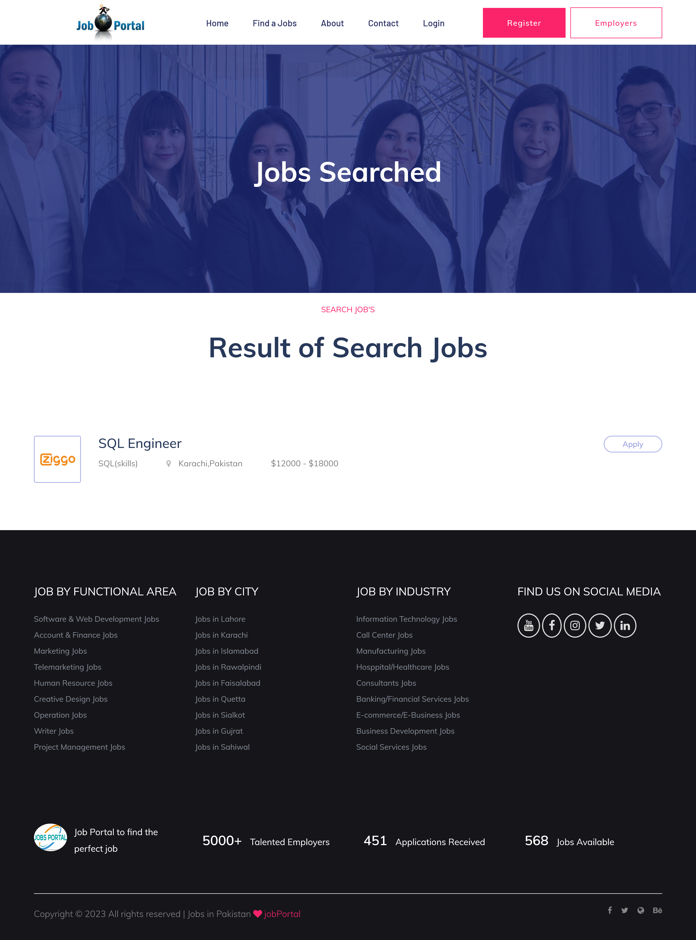

Figure 5. 8 Result of search job

### User Interface 8 - Apply for Job

Figure 5. 9 shows the apply for job screen for the job seeker. The job seeker enters all the required information than click on apply button. The application for job is submitted successfully.

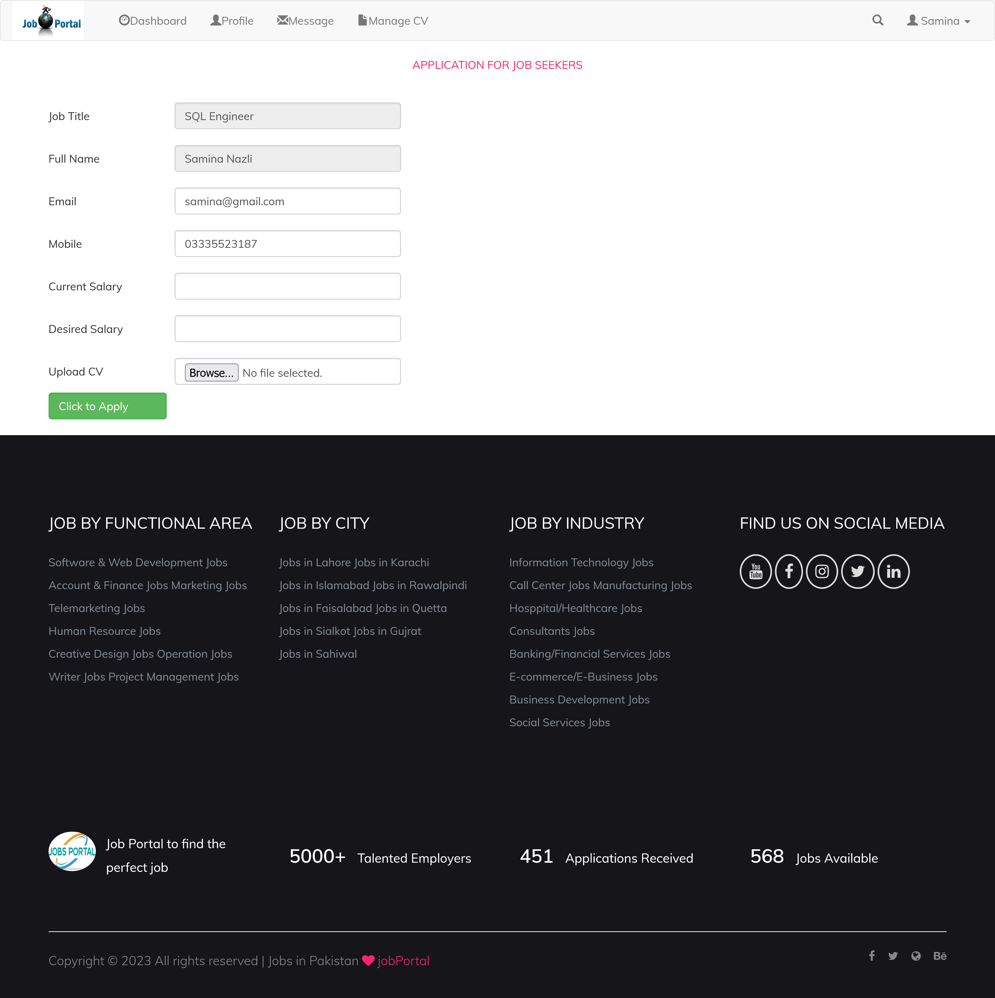

Figure 5. 9 Apply for Job

## Summary

In this chapter, we covered the database design of the proposed system. The description of the database and all the information related to the tables are in the chapter. User interfaces with their details are also in this chapter, so users understand how to interact with the proposed system. In the next chapter, we tested all the use cases of the Smart job portal.

# Chapter 6

# SYSTEM TESTING

System Testing describes the test cases of the three primary users interacting with the proposed system, which are admin, employer, and job seeker. We tested all the use case for our proposed system.



## Admin Panel Testing



### Test Case 1 – Login (Authorized)

Table 6. 1 Admin Login (Authorized) Test Case

|  |  |
| --- | --- |
| **Test ID** | TC-01 |
| **Related UC** | UC-01 |
| **Use Case** | Login |
| **Test Description** | Check the login functionality. |
| **Test Date** | 02-15-2023 |
| **Test Environment** | * OS : Windows * System: Laptop/Desktop |
| **Test Steps** | 1. Enter valid username. 2. Enter valid password. 3. Click on Login Button. |
| **Test Data** | **Username :** admin  **Password :** 123 |
| **Expected Results** | The user login successfully and he would redirect to dashboard. |
| **Actual Result** | User login and he would redirect to dashboard. |
| **Test By** | Maha Shahid (Developer) |
| **Status** | Pass |

### Test Case 2 - Login (Unauthorized)

Table 6. 2 Admin Login (Unauthorized) Test Case

|  |  |
| --- | --- |
| **Test ID** | TC-02 |
| **Related UC** | UC-01 |
| **Use Case** | Login |
| **Test Description** | Check the login functionality. |
| **Test Date** | 02-15-2023 |
| **Test Environment** | * OS : Windows * System: Laptop/Desktop |
| **Test Steps** | 1. Enter invalid username. 2. Enter invalid password. 3. Click on Login Button. |
| **Test Data** | **Username :** admin1  **Password :** 12332 |
| **Expected Results** | The error message appears and the dashboard would not appear. |
| **Actual Result** | Error message appears of invalid username and password. |
| **Test By** | Maha Shahid (Developer) |
| **Status** | Pass |

### Test Case 3 – Manage Cities

Table 6. 3 Admin Manage Cities Test Case

|  |  |
| --- | --- |
| **Test ID** | TC-03 |
| **Related UC** | UC-02 |
| **Use Case** | Manage Cities |
| **Test Description** | Check the Manage (add or update) City functionality. |
| **Test Date** | 02-15-2023 |
| **Test Environment** | * OS : Windows * System: Laptop/Desktop |
| **Test Steps** | 1. Click on manage cities. 2. Click on edit button. 3. Edit the city name or zip code. 4. Click on update button. |
| **Expected Results** | The city would be updated. |
| **Actual Result** | City is updated successfully. |
| **Test By** | Maha Shahid (Developer) |
| **Status** | Pass |

### Test Case 4 – Manage Countries

Table 6. 4 Admin Manage Countries Test Case

|  |  |
| --- | --- |
| **Test ID** | TC-04 |
| **Related UC** | UC-03 |
| **Use Case** | Manage Countries |
| **Test Description** | Check the Manage (add or update) Country functionality. |
| **Test Date** | 02-15-2023 |
| **Test Environment** | * OS : Windows * System: Laptop/Desktop |
| **Test Steps** | 1. Click on manage countries. 2. Click on edit button. 3. Edit the country name, dialing code or domain code. 4. Click on update button. |
| **Expected Results** | The country would be updated. |
| **Actual Result** | Country is updated successfully. |
| **Test By** | Maha Shahid (Developer) |
| **Status** | Pass |

### Test Case 5 - Manage Skills

Table 6. 5 Admin Manage Skills Test Case

|  |  |
| --- | --- |
| **Test ID** | TC-05 |
| **Related UC** | UC-04 |
| **Use Case** | Manage Skills |
| **Test Description** | Check the Manage (add or update) skill functionality. |
| **Test Date** | 02-15-2023 |
| **Test Environment** | * OS : Windows * System: Laptop/Desktop |
| **Test Steps** | 1. Click on manage skill. 2. Click on add new button. 3. Enter the skill name. 4. Click on update button. |
| **Expected Results** | The city would be added. |
| **Actual Result** | City is added successfully. |
| **Test By** | Maha Shahid (Developer) |
| **Status** | Pass |

### Test Case 6 – Manage Industries

Table 6. 6 Admin Manage Industries Test Case

|  |  |
| --- | --- |
| **Test ID** | TC-06 |
| **Related UC** | UC-05 |
| **Use Case** | Manage Industries |
| **Test Description** | Check the Manage (add or update) Industry functionality. |
| **Test Date** | 02-15-2023 |
| **Test Environment** | * OS : Windows * System: Laptop/Desktop |
| **Test Steps** | 1. Click on manage industry. 2. Click on add new button. 3. Add the name of industry. 4. Click on add button. |
| **Expected Results** | The industry would be added. |
| **Actual Result** | Industry is added successfully. |
| **Test By** | Maha Shahid (Developer) |
| **Status** | Pass |

### Test Case 7 – Approve Member profile

Table 6. 7 Admin Approve Member Profile Test Case

|  |  |
| --- | --- |
| **Test ID** | TC-07 |
| **Related UC** | UC-06 |
| **Use Case** | Approve Member Profile |
| **Test Description** | Check the approve member profile functionality. |
| **Test Date** | 02-15-2023 |
| **Test Environment** | * OS : Windows * System: Laptop/Desktop |
| **Test Steps** | 1. Click on Approve Member profile. 2. Click on view button. 3. All information of member show in a form. 4. Click on approved button. |
| **Expected Results** | The member profile would be approved. |
| **Actual Result** | Member profile is approved successfully. |
| **Test By** | Maha Shahid (Developer) |
| **Status** | Pass |

### Test Case 8 – Approve Job Advertisement

Table 6. 8 Admin Approve Job Advertisement Test Case

|  |  |
| --- | --- |
| **Test ID** | TC-08 |
| **Related UC** | UC-07 |
| **Use Case** | Approve Job Advertisement |
| **Test Description** | Check the approve job advertisement functionality. |
| **Test Date** | 02-15-2023 |
| **Test Environment** | * OS : Windows * System: Laptop/Desktop |
| **Test Steps** | 1. Click on Approve Job Advertisement. 2. Click on view button. 3. All information of related to job shown in a form. 4. Click on approved button. |
| **Expected Results** | The job advertisement would be approved. |
| **Actual Result** | Job advertisement is approved successfully. |
| **Test By** | Maha Shahid (Developer) |
| **Status** | Pass |



## Employer Panel Testing



### Test Case 1 – Sign Up

Table 6. 9 Employer Signup Test Case

|  |  |
| --- | --- |
| **Test ID** | TC-09 |
| **Related UC** | UC-09 |
| **Use Case** | Sign Up |
| **Test Description** | Check the sign up functionality. |
| **Test Date** | 02-16-2023 |
| **Test Environment** | * OS : Windows * System: Laptop/Desktop |
| **Test Steps** | 1. Click on Sign Up button. 2. Enter the first name, last name, email, company came, password, mobile number, city name & CNIC. 3. Click on create account button. 4. For verification, email is send to your registered email. |
| **Expected Results** | The registration would be done. |
| **Actual Result** | Registration is done successfully. |
| **Test By** | Maha Shahid (Developer) |
| **Status** | Pass |

### Test Case 2 - Login

Table 6. 10 Employer Login Test Case

|  |  |
| --- | --- |
| **Test ID** | TC-10 |
| **Related UC** | UC-10 |
| **Use Case** | Login |
| **Test Description** | Check the login functionality. |
| **Test Date** | 02-16-2023 |
| **Test Environment** | * OS : Windows * System: Laptop/Desktop |
| **Test Steps** | 1. Enter valid email. 2. Enter valid password. 3. Click on Login Button. |
| **Test Data** | **Email :** mahashahid124@gmail.com  **Password :** maha@123 |
| **Expected Results** | The user login successfully and he would redirect to dashboard. |
| **Actual Result** | User login and he would redirect to dashboard. |
| **Test By** | Maha Shahid (Developer) |
| **Status** | Pass |

### Test Case 3 – Forgot Password

Table 6. 11 Employer Forgot Password Test Case

|  |  |
| --- | --- |
| **Test ID** | TC-11 |
| **Related UC** | UC-11 |
| **Use Case** | Forgot Password |
| **Test Description** | Check the forgot password functionality. |
| **Test Date** | 02-16-2023 |
| **Test Environment** | * OS : Windows * System: Laptop/Desktop |
| **Test Steps** | 1. Enter the valid email. 2. Enter the invalid password. 3. Click on Login Button. 4. User gets an error message. 5. Click on forgot password. 6. User would redirect to next page where he would have to enter his valid email. 7. Click on continue. 8. The password is send to his email. |
| **Expected Results** | The valid password would send to email. |
| **Actual Result** | Valid password send to email. |
| **Test By** | Maha Shahid (Developer) |
| **Status** | Pass |

### Test Case 4 – Post a job

Table 6. 12 Employer Post a Job Test Case

|  |  |
| --- | --- |
| **Test ID** | TC-12 |
| **Related UC** | UC-13 |
| **Use Case** | Post a Job advertisement |
| **Test Description** | Check the post job advertisement functionality. |
| **Test Date** | 02-16-2023 |
| **Test Environment** | * OS : Windows * System: Laptop/Desktop |
| **Test Steps** | 1. Click on post a job button. 2. Enter the job title, job description, skills, location, career level, No. of positions, Qualification, Years of experience & salary. 3. Click on post a job button. |
| **Expected Results** | The job advertisement would be posted. |
| **Actual Result** | Job advertisement would be posted successfully. |
| **Test By** | Maha Shahid (Developer) |
| **Status** | Pass |

### Test Case 5 – Manage Jobs

Table 6. 13 Employer Manage Jobs Test Case

|  |  |
| --- | --- |
| **Test ID** | TC-13 |
| **Related UC** | UC-14 |
| **Use Case** | Manage Job advertisements |
| **Test Description** | Check the Manage (update or delete) job advertisement functionality. |
| **Test Date** | 02-16-2023 |
| **Test Environment** | * OS : Windows * System: Laptop/Desktop |
| **Test Steps** | 1. Click on Manage jobs. 2. The user would see all the jobs which are posted. 3. Click on update button. 4. The user would update the job title, job description etc. 5. Click on update button.   OR   1. Click on manage jobs. 2. The user would see all the jobs which are posted. 3. Click on delete button. |
| **Expected Results** | The job advertisement would be updated or deleted. |
| **Actual Result** | Job advertisement would be updated or deleted successfully. |
| **Test By** | Maha Shahid (Developer) |
| **Status** | Pass |

### Test Case 6 – View or download CVs

Table 6. 14 Employer View or download CV’s Test Case

|  |  |
| --- | --- |
| **Test ID** | TC-14 |
| **Related UC** | UC-15 |
| **Use Case** | View or download |
| **Test Description** | Check the view or download CV functionality. |
| **Test Date** | 02-16-2023 |
| **Test Environment** | * OS : Windows * System: Laptop/Desktop |
| **Test Steps** | 1. Click on manage CVs. 2. All CV’s are appeared. 3. Click on view button.   OR   1. Click on download button. |
| **Expected Results** | The CV would view or downloaded. |
| **Actual Result** | CV would be view or downloaded successfully. |
| **Test By** | Maha Shahid (Developer) |
| **Status** | Pass |



## Job Seeker Panel Testing



### Test Case 1 – Sign Up

Table 6. 15 Job Seeker SignUp Test Case

|  |  |
| --- | --- |
| **Test ID** | TC-15 |
| **Related UC** | UC-08 |
| **Use Case** | Sign Up |
| **Test Description** | Check the sign up functionality. |
| **Test Date** | 02-16-2023 |
| **Test Environment** | * OS : Windows * System: Laptop/Desktop |
| **Test Steps** | 1. Enter the first name. 2. Enter the last name. 3. Enter the email. 4. Enter the password. 5. Enter the mobile number. 6. Click on create account button. 7. For verification, email is send to your registered email. |
| **Expected Results** | The registration would be done. |
| **Actual Result** | Registration is done successfully. |
| **Test By** | Maha Shahid (Developer) |
| **Status** | Pass |

### Test Case 2 - Login

Table 6. 16 Job Seeker login Test Case

|  |  |
| --- | --- |
| **Test ID** | TC-16 |
| **Related UC** | UC-10 |
| **Use Case** | Login |
| **Test Description** | Check the login functionality. |
| **Test Date** | 02-16-2023 |
| **Test Environment** | * OS : Windows * System: Laptop/Desktop |
| **Test Steps** | 1. Enter valid email. 2. Enter valid password. 3. Click on Login Button. |
| **Expected Results** | The user login successfully and he would redirect to dashboard. |
| **Actual Result** | User login and he would redirect to dashboard. |
| **Test By** | Maha Shahid (Developer) |
| **Status** | Pass |

### Test Case 3 – Forgot password

Table 6. 17 Job Seeker Forgot Password Test Case

|  |  |
| --- | --- |
| **Test ID** | TC-17 |
| **Related UC** | UC-11 |
| **Use Case** | Forgot Password |
| **Test Description** | Check the forgot password functionality. |
| **Test Date** | 02-16-2023 |
| **Test Environment** | * OS : Windows * System: Laptop/Desktop |
| **Test Steps** | 1. Enter the valid email. 2. Enter the invalid password. 3. Click on Login Button. 4. User gets an error message. 5. Click on forgot password. 6. User would redirect to next page where he would have to enter his valid email. 7. Click on continue. 8. The password is send to his email. |
| **Expected Results** | The valid password would send to email. |
| **Actual Result** | Valid password send to email. |
| **Test By** | Maha Shahid (Developer) |
| **Status** | Pass |

### Test Case 4 – Search Jobs

Table 6. 18 Job Seeker Search Job Test Case

|  |  |
| --- | --- |
| **Test ID** | TC-18 |
| **Related UC** | UC-14 |
| **Use Case** | Search Job |
| **Test Description** | Check the search job functionality. |
| **Test Date** | 02-16-2023 |
| **Test Environment** | * OS : Windows * System: Laptop/Desktop |
| **Test Steps** | 1. Enter the job title. 2. Select the city. 3. Click on search button. |
| **Expected Results** | The job would be searched. |
| **Actual Result** | Job searched successfully. |
| **Test By** | Maha Shahid (Developer) |
| **Status** | Pass |

### Test Case 5 – Apply for job

Table 6. 19 Job Seeker Apply job Test Case

|  |  |
| --- | --- |
| **Test ID** | TC-19 |
| **Related UC** | UC-15 |
| **Use Case** | Apply for Job |
| **Test Description** | Check the apply for job functionality. |
| **Test Date** | 02-16-2023 |
| **Test Environment** | * OS : Windows * System: Laptop/Desktop |
| **Test Steps** | 1. Enter the job title. 2. Select the city. 3. Click on search button. 4. Jobs searched successfully. 5. Click on apply button. 6. Enter the current salary. 7. Enter the desired salary. 8. Upload your CV. 9. Click on save button. |
| **Expected Results** | The job application would be submitted. |
| **Actual Result** | Job application submitted successfully. |
| **Test By** | Maha Shahid (Developer) |
| **Status** | Pass |

## Summary

In this chapter, we covered the test cases for our proposed system. All the functional requirements are tested. The users of Smart Job Portal are admins, employers, and job seekers. In the next chapter, we discussed the user manual.

# Chapter 7

# USER MANUAL



## Login

* + - 1. Open the smart job portal **website**.
      2. Click on login.
      3. Enter the **email**.
      4. Enter the **password**.
      5. Click **Login** button**.**
      6. After click on login, the users would redirect to dashboard.



Figure 7. 1 Login

## Post a Job

Click on **post a job** button.

The required fields are Job **Title**, Job **Description**, skills, career level, No. of positions, Qualification, Years of experience, salary range.

Enter all these fields or fill all the above-mentioned fields.

Click on **post a job**.



Figure 7. 2 Post a Job

## Search Job

Open the Smart Job Portal Website.

Enter the **job title**.

Select the **city**.

Click on **Search** button.



Figure 7. 3 Search a Job

## Apply for Job

Open the Smart Job Portal Website.

Enter the **job title**.

Select the **city**.

Click on **Search** button.

Click on apply button.

Enter the **current** salary.

Enter the **desired** salary.

Upload the **CV**.

Click on Apply button.



Figure 7. 4 Apply for Job

## View and Download CV’s

Click on **Manage CV’s.**

Click on **view** button.

The CV viewed successfully.

Click on **download** button.

The CV downloaded successfully.



Figure 7. 5 View or Download CV’s

## Summary

In this chapter, we describe the user manual of our proposed system. The user interacts with the website by following the steps. We are adding the diagrams of our proposed system for better understanding. The user will sign up into the smart job portal. He will log in to the site. After login, he posts a job and manages job advertisements. He will also view and download the CV.

# Chapter 8

# CONCLUSION & FUTURE WORK



## Conclusion

Smart Job Portal has been developed for job seekers and employers in which job seekers can search for a specific job according to their qualifications, skills, and interests. He can also apply for a job that matches their interests. Employers can post job advertisements that are vacant in their company. The employer can update or delete the job advertisements as well. The proposed system also provides verification of employers and job seekers when they signup in Smart Job Portal. Companies can find the right candidate for the right job very efficiently using the Smart Job Portal.

## Future Work

In the future, we will include the feature of messaging for job seekers & employers. They can send and receive messages within the site. We will also work on the functionality that we apply restriction of skills and locations. In this functionality, the job seeker would not apply for a job that does not match their skills. The job seeker would not be able to apply for a job not suitable for their location.

# REFERENCES

*ASP .Net*. (n.d.). Retrieved from https://dotnet.microsoft.com/en-us/apps/aspnet

*Bootstrap*. (n.d.). Retrieved from https://getbootstrap.com/

*Color Hunt*. (n.d.). Retrieved from https://colorhunt.co/

*Indeed*. (n.d.). Retrieved from https://pk.indeed.com/?r=us

*Lucid Chart*. (n.d.). Retrieved from https://www.lucidchart.com/pages/uml-use-case-diagram

*Micrrosoft Visio*. (n.d.). Retrieved from https://www.microsoft.com/en-us/microsoft-365/visio/flowchart-software

*Monster*. (n.d.). Retrieved from https://www.monster.com/

*Relaibility*. (n.d.). Retrieved from https://requirementsquest.com/nonfunctional-requirement-examples/

*Rozee*. (n.d.). Retrieved from https://www.rozee.pk/

*Software Testing*. (n.d.). Retrieved from https://www.techtarget.com/whatis/definition/software-testing

*SQL Server Management Studio*. (n.d.). Retrieved from https://learn.microsoft.com/en-us/sql/ssms/download-sql-server-management-studio-ssms?view=sql-server-ver16

*Test Case*. (n.d.). Retrieved from https://www.browserstack.com/guide/how-to-write-test-cases#:~:text=A%20test%20case%20refers%20to,necessary%20to%20verify%20a%20feature.

*Visual Studio*. (n.d.). Retrieved from https://visualstudio.microsoft.com/

*w3Schools*. (n.d.). Retrieved from https://www.w3schools.com/